Data Mining Project - Thera Bank

Submitted by
Renjith Mohan K
04/19/2020

1 Project Objective
The objective of the project is to use the dataset 'Thera Bank.xlsx' and apply CART and Random Forest models on it and compare their performance.As a part of it, we will be performing the below activities -

EDA - Basic data summary, Univariate, Bivariate analysis, graphs
Applying CART <plot the tree>
Interpret the CART model output <pruning, remarks on pruning, plot the pruned tree>
Applying Random Forests<plot the tree>
Interpret the RF model output <with remarks, making it meaningful for everybody>
Confusion matrix interpretation
Interpretation of other Model Performance Measures < AUC, ROC>
Remarks on Model validation exercise <Which model performed the best>

2 Assumptions
We assume that the if some values in the dataset is mentioned as negative, we will treat them as absolute and change to positive.

3 Exploratory Data Analysis – Step by step approach
A Typical Data exploration activity consists of the following steps:

1. Environment Set up and Data Import
2. Variable Identification
3. Missing Value Treatment
4. Outlier Treatment
5. Variable Transformation
6. Univariate Analysis
7. Bi-Variate Analysis
8. Variable Transformation
9. Feature Exploration

3.1 Environment Set up and Data Import
3.1.1 Install necessary Packages and Invoke Libraries
As a part of this problem, we installed the below packages and afterwards loaded into library with the aid of library() function.

Please refer Appendix A for Source Code

3.1.2 Set up working Directory
Setting a working directory on starting of the R session makes importing and exporting data
files and code files easier. Here the working directory is chosen as C:/2020/RProgramming/DataMining where we have the data sets, codes etc. related to the project. We do this with the aid of setwd() function.

Please refer Appendix A for Source Code

3.1.3 Import and Read the Dataset
The given dataset is in .xlsx format. Hence, the command “read_excel” is used for importing the
file.

Please refer Appendix A for Source Code.

3.2 EDA - Basic data summary, Univariate, Bivariate analysis, graphs

Approach: For basic data summary /variable identification, we use the R functions - dim, names, str, summary, head, tail. The purpose of each of the functions are briefly mentioned below -

dim - we use this to get the dimension of the data frame meaning the number of rows and columns.
names - we use this to identify the colum/variable names. For this data set , we make changes to the column names accordingly.
str - we use this to get the structure of the variable/column names like factor, integer or numeric.
summary - we use this to get a summary of the column names. It gives us the 5 point summary with details of min, max. Median, 25th percentile & 75th percentile.Basically we perform descriptive statistic with this one.
head - we use this to check a sample of data from the data frame. By default it gives the first 6 records.
tail - we use this also to check sample records from the data frame. By default it gives the last 6 records.

Please refer Appendix A for Source Code.

3.2.1 EDA - Basic data Inference

Below are the inferences from the above EDA step -

Using “dim”, we identified that the Factor Hair data set has 5000 rows and 13 columns. We also verified that the column names are proper and from “str” command, all available variables are numeric and Factor in nature. We rename the columns in the dataset properly. We also confirmed that the data is proper by checking first and last 6 records by using the head and tail functions.

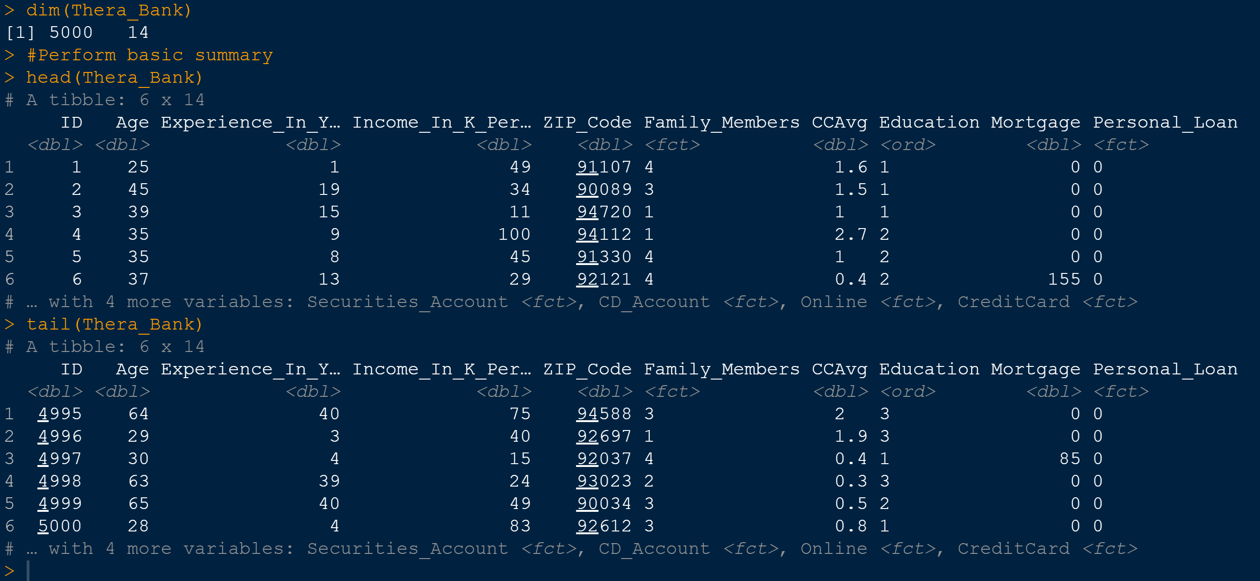

Please refer Appendix A for Source Code.

Missing Value Treatment
From is.na() we identified that we have missing values for Family_Members. So we convert them into zeroes before proceeding ahead.Also for the variable Experience, we notice that there are some negative values and we use an abs() to convert them into positive values.
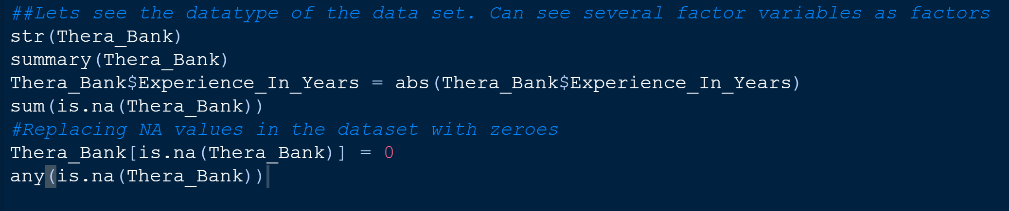

Outlier Treatment

We check for outliers using boxplot and we do a treatment to remove those values from the dataset. The outlier treatment is being performed for the variables - Income_In_K_Peryear, CCAvg, Mortgage. The treatment is done in such a way that any value greater than 75th percentile + 1.5 * IQR is limited to 95th percentile value and all values lower than 25th percentile - 1.5 *IQR is limited to 5th percentile.

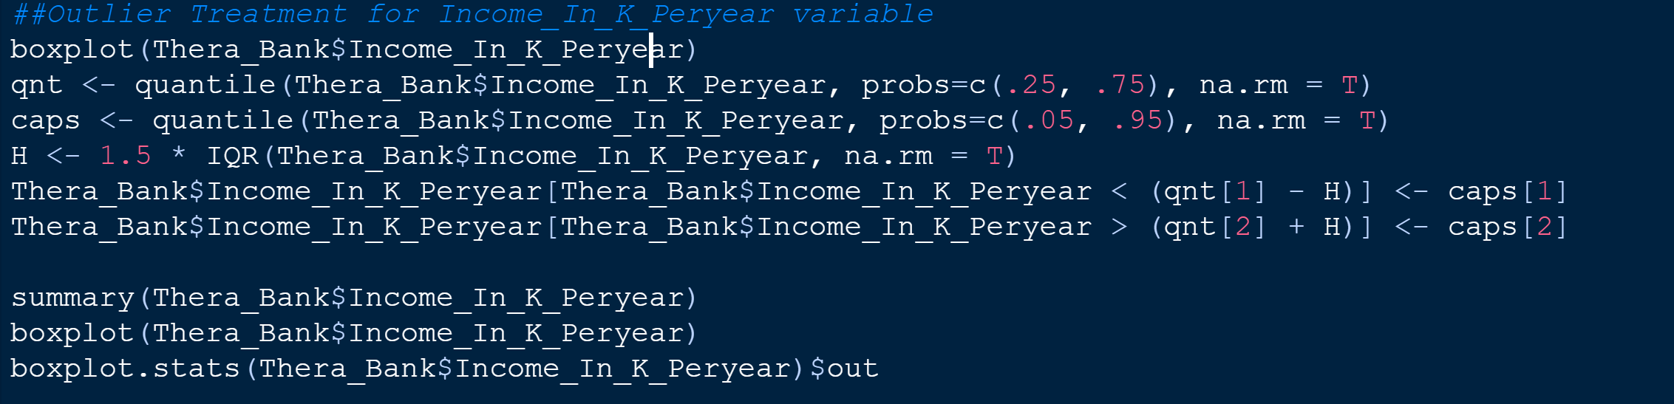

Here we convert some of the numeric variables into factors as below and for Education, we convert it into an Ordered Factor.
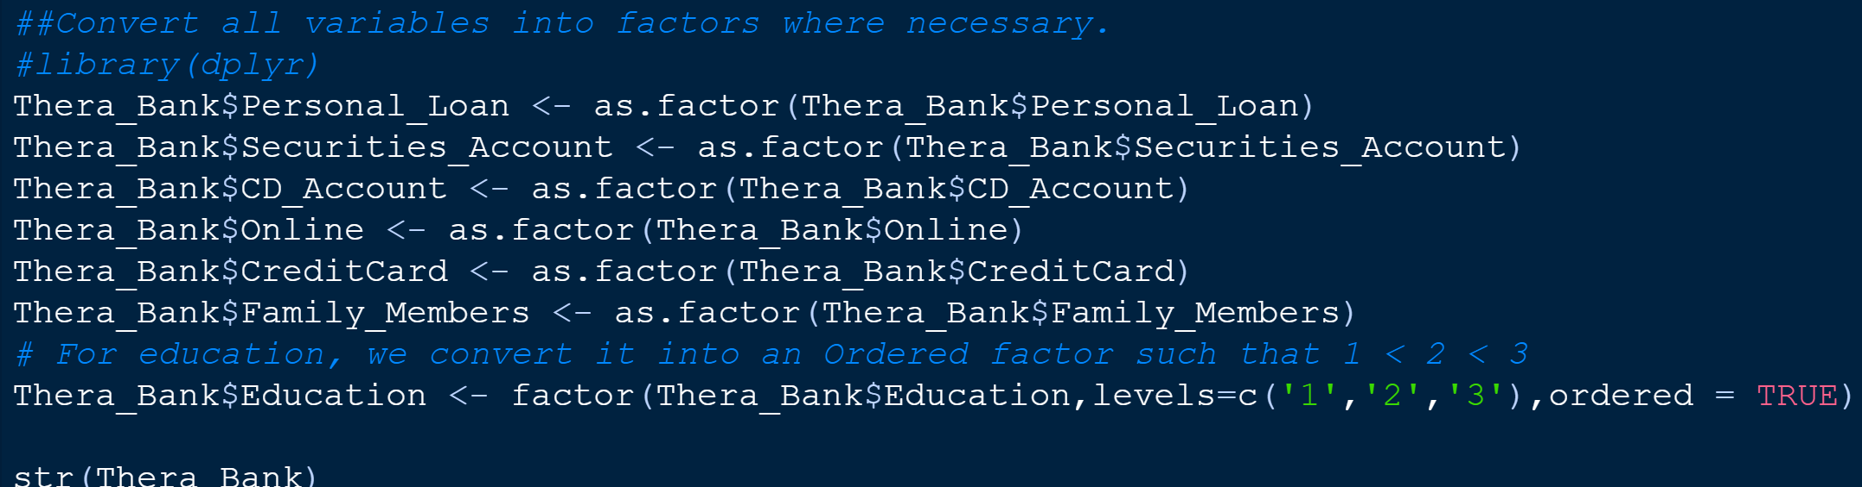

3.2.2 EDA - Uni-variate Analysis

Approach: Use Histogram, Boxplots

From this histogram below, we can see that the variables - Age, Experience are uniformally distributed whereas the variables CCAvg and Income seems to have outliers. The variables Mortgage seem to have outliers where as all zipcode seem to be there from a particular location.

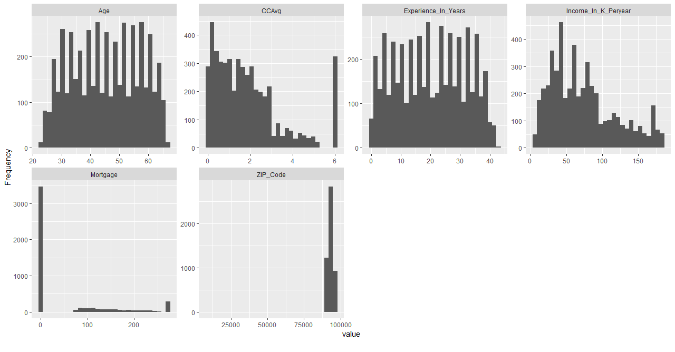
Observation: Most of the customers belong to from 1 family member family.In a similar fashion, The Education level for most of the customers is only -1 meaning Undergraduates.Most of the customers also looks like not having a credit card , CD_Account or Securities Account.
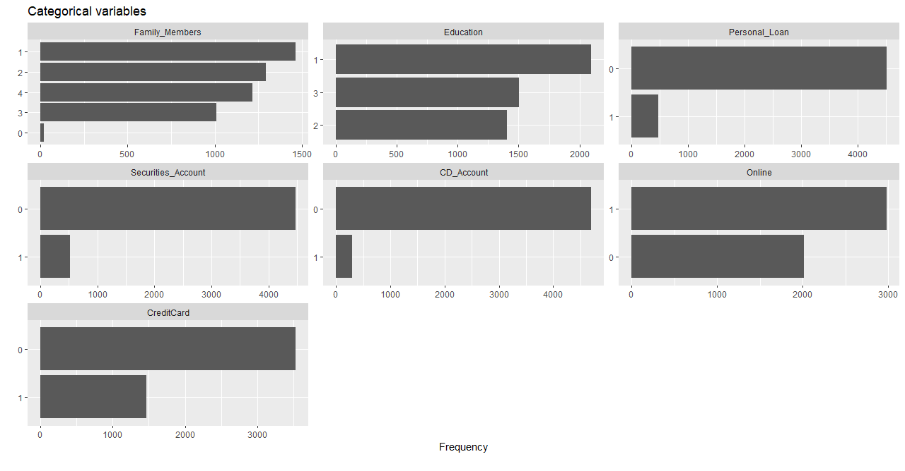
Boxplot by Education

Observation: From the data it appears that CcAvg has outliers for Education Category = 2/3 and same is the trend for Income as well.
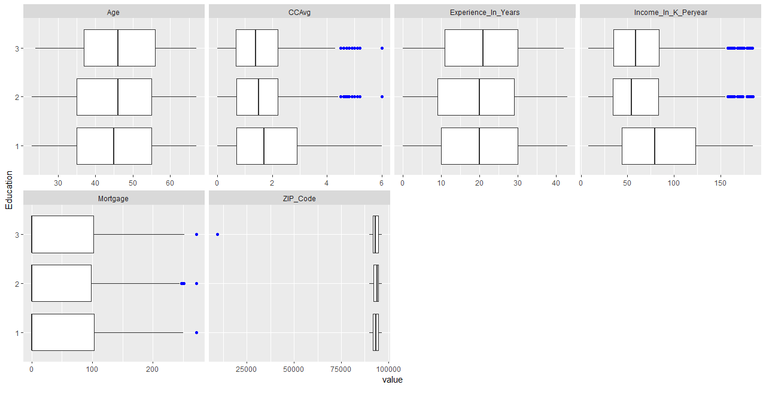
Boxplot by Personal_Loan

Observation: From the data it appears that CCAvg has outliers for only no Personal_Loan category. The same trend is observed for Income and Mortgage also.

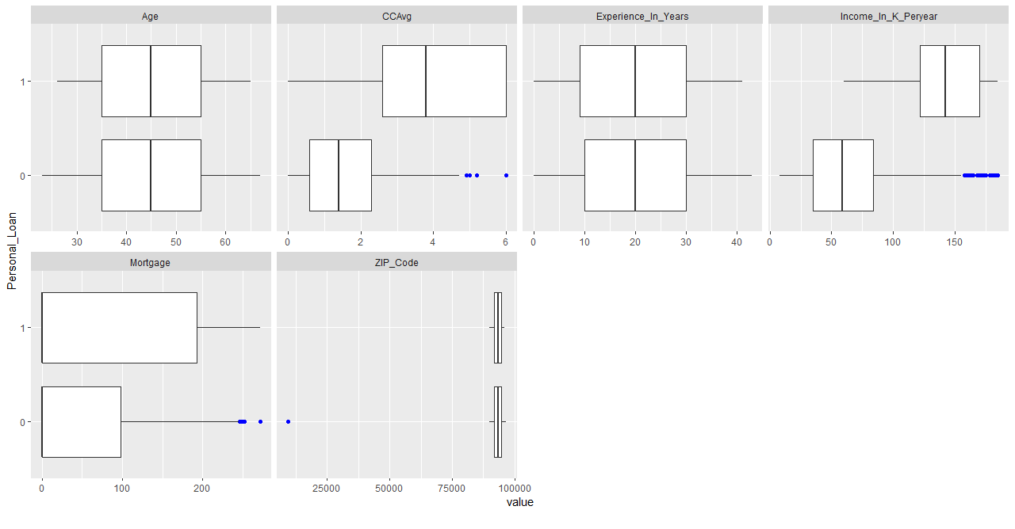

Boxplot by Family_Members

Observation: From the data it appears that CCAvg has outliers for Family Members = 3/4 category. For Motgage, we are seeing outliers across all categories.

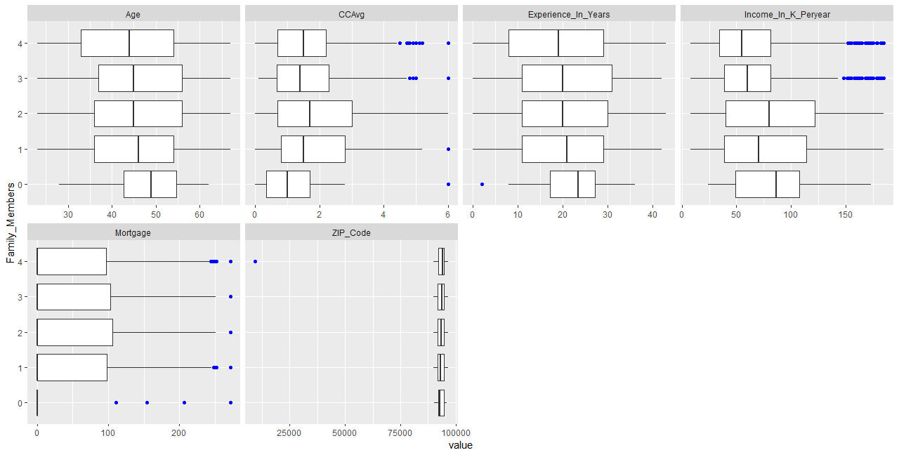
3.2.3 EDA - Bi-variate Analysis

Density Plots:

Observations : Age doesn’t seem to have much of an impact on a person taking up a loan.

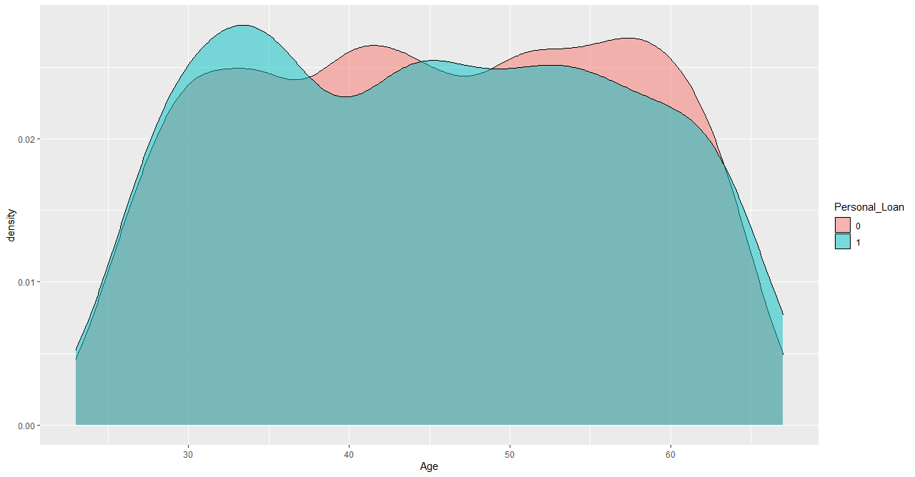

Observations : Experience of the customer doesn’t seem to have much of an impact on a person taking up a loan.

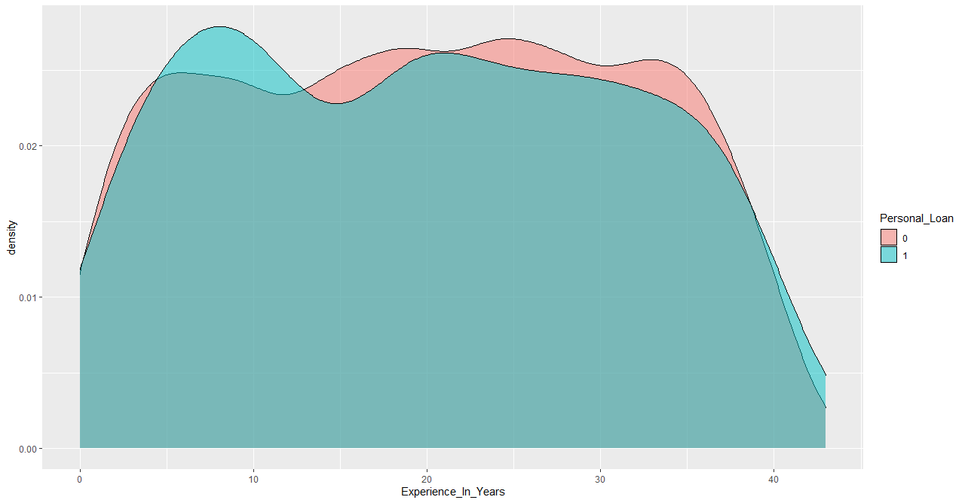
Observations : Income of the customer seem to be significant factor for a customer taking up a loan.

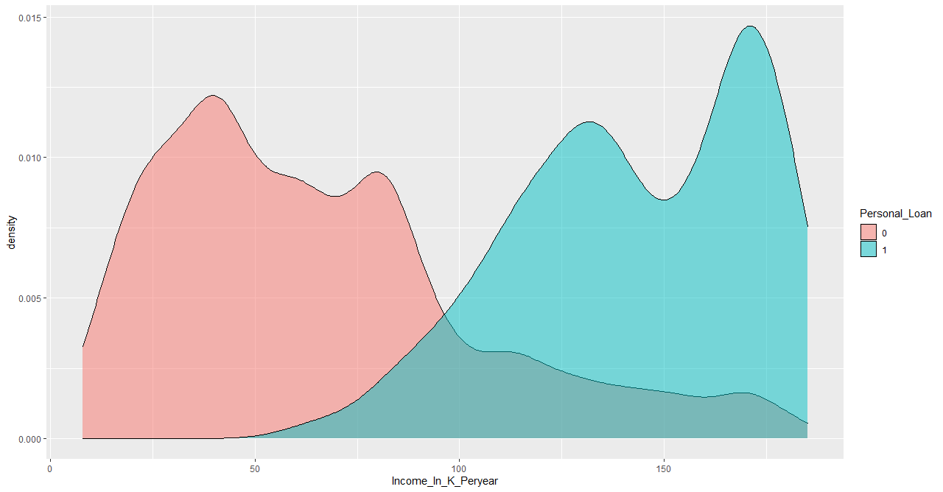

Observations : Mortgage of the customer doesn’t seem to be significant factor for a customer taking up a loan.
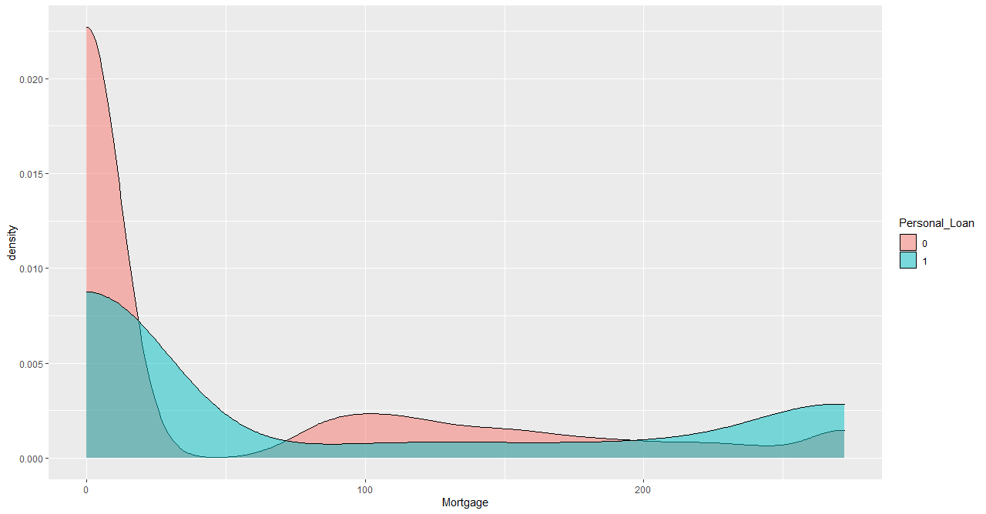

Scatter Plots:
Observation: We can see that as the Income of the person increases, there is a higher chance of that person taking up the loan.

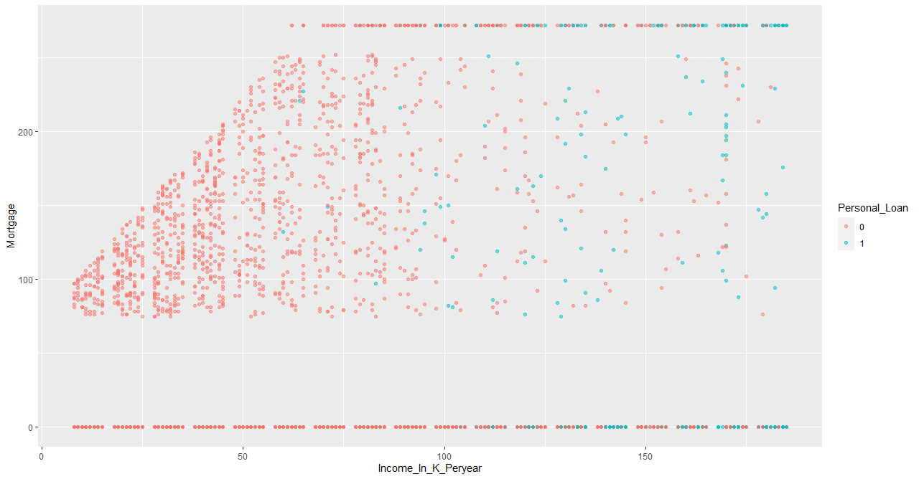
Observation: We can see that as the CcAvgof the person increases, there is a higher chance of that person taking up the loan.

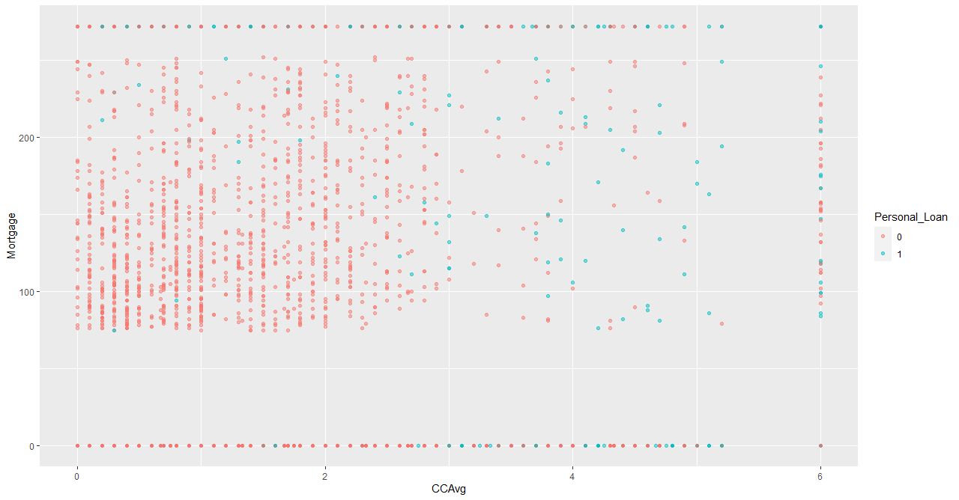

Barplots:

Observations : We can see that as the number of family members increases, there is a higher chance of that person taking up the loan

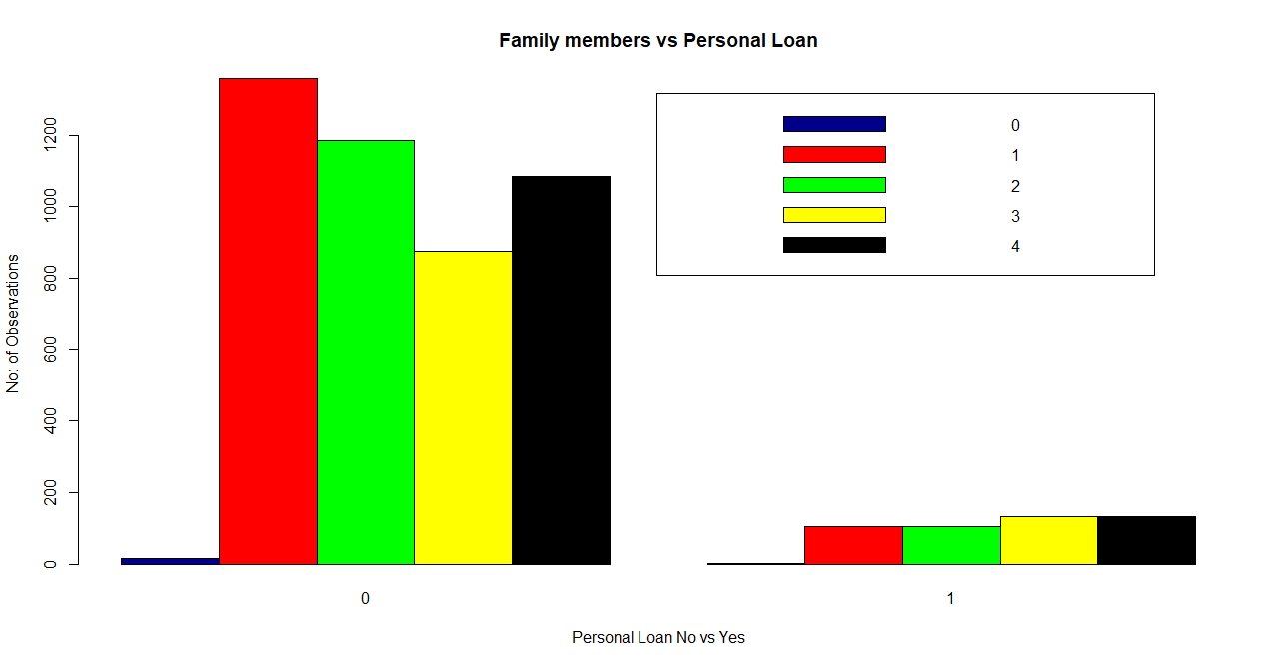
Observation: We can see that as the educational qualification of the person increases, there is a higher chance of that person taking up the loan.
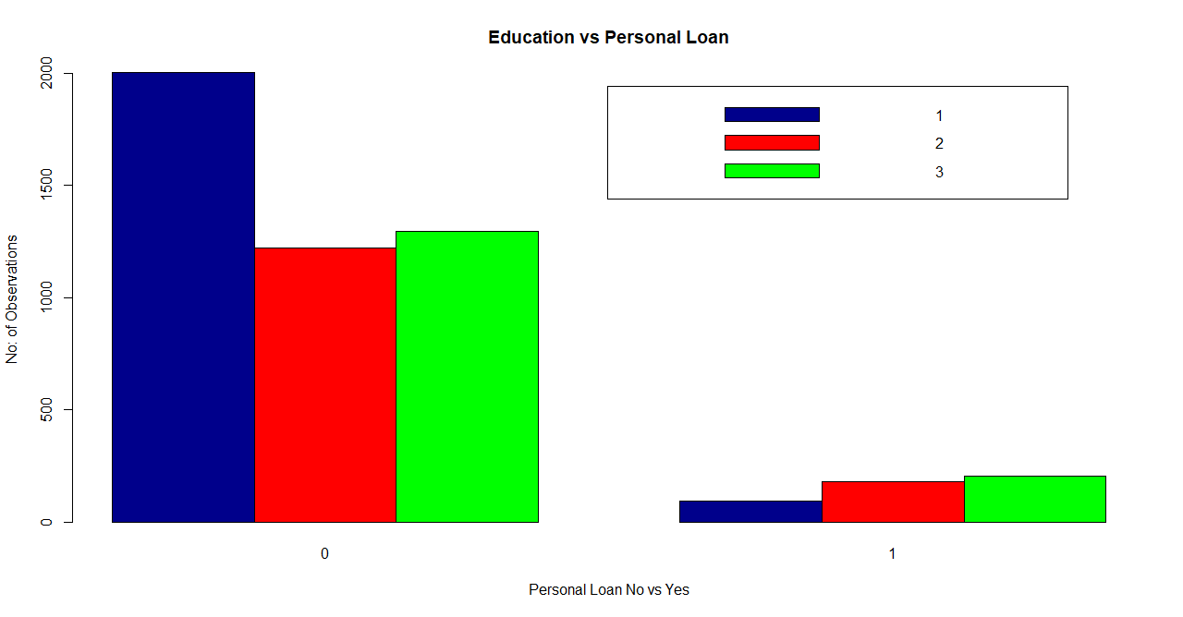

Multi Plot

Observations : From the below plots, we could see that there is good correlation between CCAvg and Mortgageand also b/w Income and Mortgage, which are continuous variables.

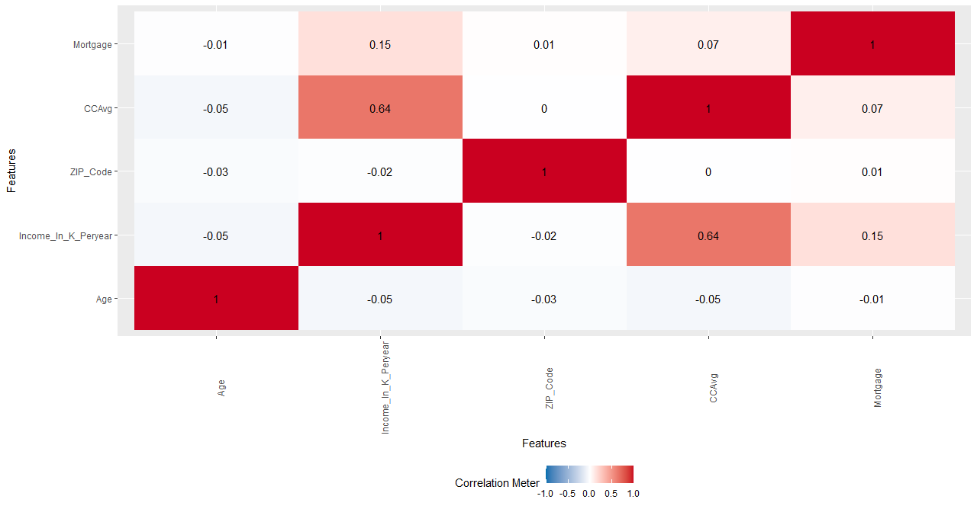

Please refer Appendix A for Source Code.

3.3.3 EDA Summary & Structure of data set

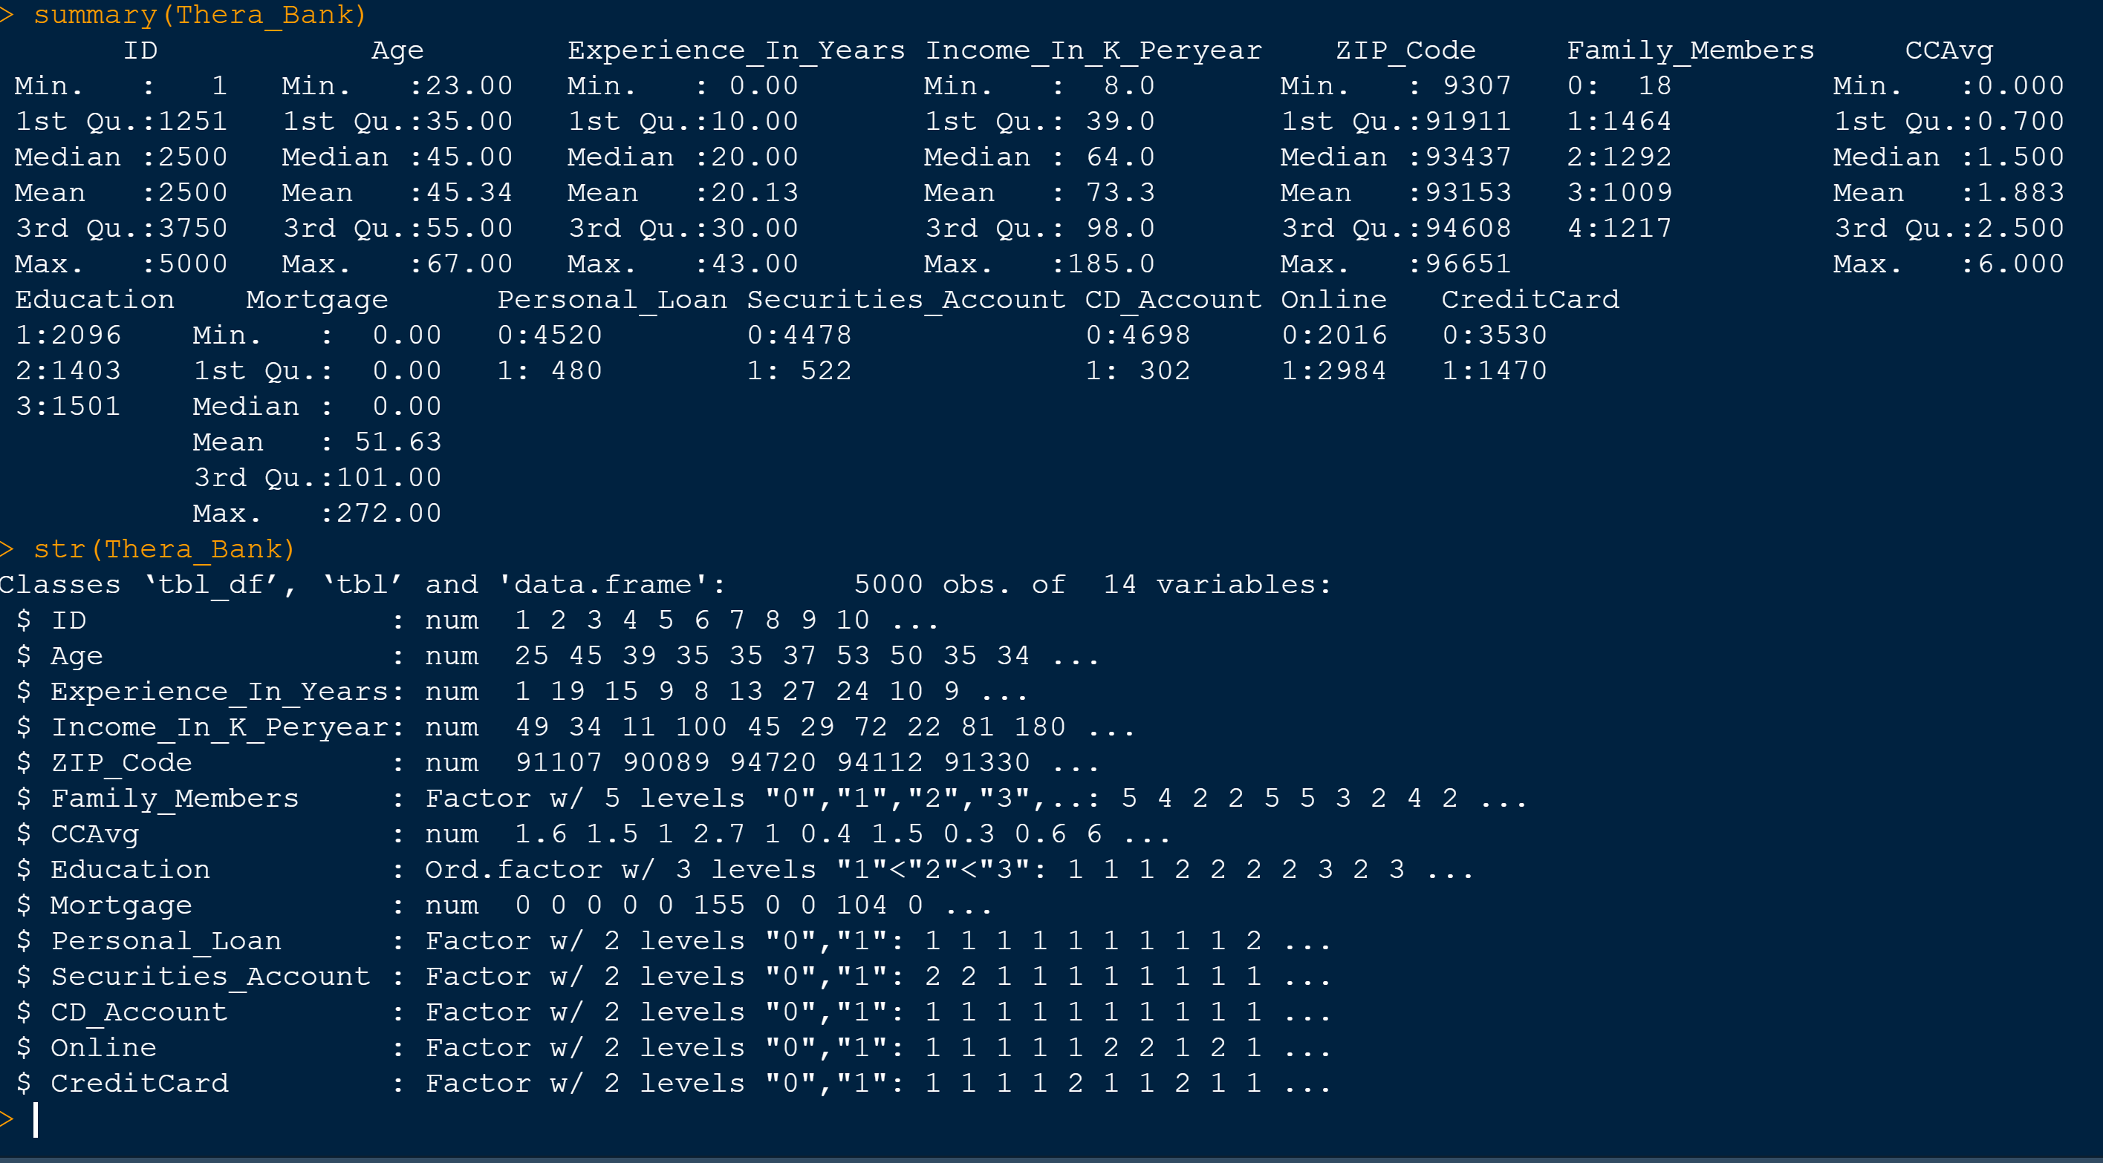

Please refer Appendix A for Source Code.

3.4 Applying CART
A CART tree is a binary decision tree that is constructed by splitting a node into two child nodes repeatedly, beginning with the root node that contains the whole learning sample.A classification tree is an algorithm where the target variable is fixed or categorical. The algorithm is then used to identify the “class” within which a target variable would most likely fall. In our problem, we perform classification tree with the target variable as Personal_Loan. At the end of the analysis, we will plot a CART tree. We use the libraries rpart and rpart.plot for this purpose.

We will be splitting our data into train and test with a split of 70:30 and first train our model with 70 percentage of the data set and finally test it with remaining 30 percentage.These calculations are included in the model performance section

Initially we performed the CART analysis with train data which has a total of 3500 observations(70% of the data).The parameters used are -
- minsplit is “the minimum number of observations that must exist in a node in order for a split to be attempted” --> We chose it as 100 to start with
- minbucket is “the minimum number of observations in any terminal node. We chose it as 10 to start with.
- Cp is complexity parameter which we chose as 0
- Xval is Crossvalidation which we took as 10

Tree Plot
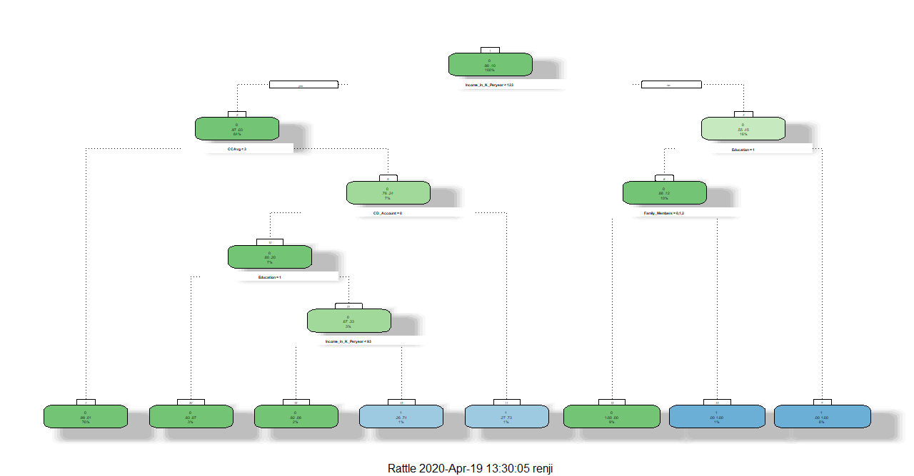

Model Output
> m1n= 3500

node), split, n, loss, yval, (yprob)
* denotes terminal node

1) root 3500 336 0 (0.904000000 0.096000000)
2) Income_In_K_Peryear< 122.5 2928 78 0 (0.973360656 0.026639344)
4) CCAvg< 2.95 2673 16 0 (0.994014216 0.005985784) *
5) CCAvg>=2.95 255 62 0 (0.756862745 0.243137255)
10) CD_Account=0 233 46 0 (0.802575107 0.197424893)
20) Education=1 118 8 0 (0.932203390 0.067796610) *
21) Education=2,3 115 38 0 (0.669565217 0.330434783)
42) Income_In_K_Peryear< 92.5 72 6 0 (0.916666667 0.083333333) *
43) Income_In_K_Peryear>=92.5 43 11 1 (0.255813953 0.744186047) *
11) CD_Account=1 22 6 1 (0.272727273 0.727272727) *
3) Income_In_K_Peryear>=122.5 572 258 0 (0.548951049 0.451048951)
6) Education=1 357 43 0 (0.879551821 0.120448179)
12) Family_Members=0,1,2 314 0 0 (1.000000000 0.000000000) *
13) Family_Members=3,4 43 0 1 (0.000000000 1.000000000) *
7) Education=2,3 215 0 1 (0.000000000 1.000000000) *

3.4.1 Interpret the CART model output
We see from CART output that the most important variable for splitting is Income_In_K_Peryear and with a split condition that it is greater than or less than the value 123. The other important variables upon which the split happened at next layer is CCAvg with condition less than or greater/equal to 3 and for Education with value 1 or not equal to 1.In the next layer, split happened with the variables CD_Account and Family_Members. The final split happened with Education=1 and Income_In_K_Peryear < 93. At the end we have a tree with 8 leaf nodes.

Note that the variables - Age, Experience_In_Years, ZIP_Code, Mortgage, Securities_Account,Online, Credit_Card are not the part of tree and hence we can conclude that they are less influential in tree building.

We do the pruning by chosing the CP as 0.024 for which we get the lowest Xerror. We see that a lot of pruning happened wrt the initial tree. The split comprising of the variable Income_In_K_Peryear with a condition <123and >= 123 is the primary split. In the Pruned output, this tree and subsequent nodes have been removed. Finally we have an output with 6 leaf nodes. And we deduct from the tree that the best split ( with 84% of the data) had the node path of Income_In_K_Peryear < 123K and that node result in the condition of Personal_Loan =0. This means that people who follow this path are not likely to take a loan.

And as far for the condition , Personal_Loan=1 goes right, the best node path we see is Income_In_K_Peryear > 123K --> Education not equal to 1. The customers who follows this path are likely to take up a loan.

Finally after pruning we were able to reduce the total number of leaf nodes from 8 to 4.The important variables we identified as a part of this process are - Income_In_K_Peryear, Education, Family_Members in the order mentioned.

CP Vs XRelativeError Plot
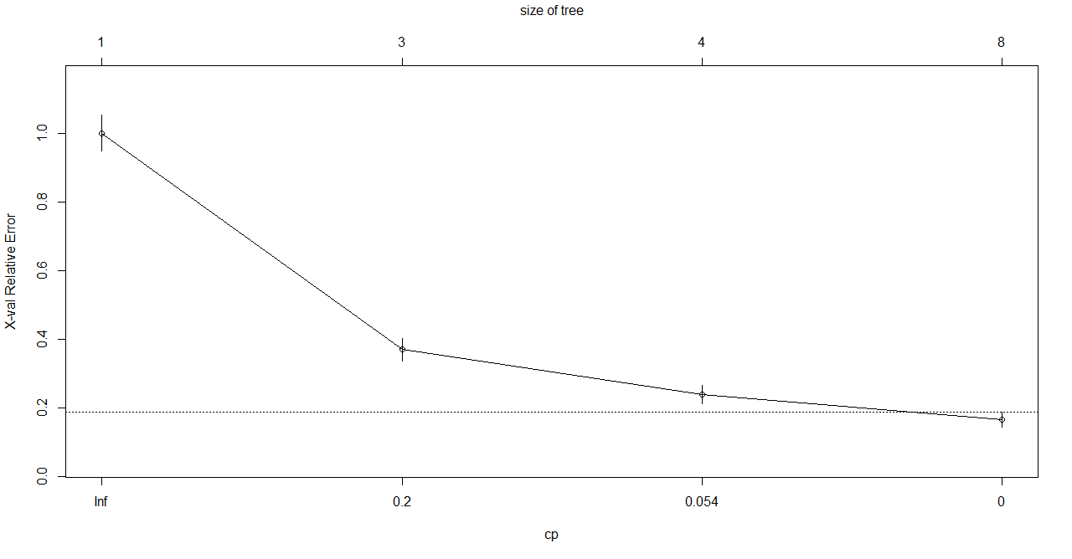
CP chosen = 0.0024 after looking at the least Xerror.

Variables actually used in tree construction:
[1] CCAvg CD_Account Education Family_Members Income_In_K_Peryear

Root node error: 336/3500 = 0.096

n= 3500

CP nsplit rel error xerror xstd
1 0.319940 0 1.00000 1.00000 0.051870
2 0.127976 2 0.36012 0.36905 0.032549
3 0.023065 3 0.23214 0.23810 0.026314
4 0.000000 7 0.13988 0.16369 0.021898

Pruned model output
> m1_prunedn= 3500

node), split, n, loss, yval, (yprob)
* denotes terminal node

1) root 3500 336 0 (0.90400000 0.09600000)
2) Income_In_K_Peryear< 122.5 2928 78 0 (0.97336066 0.02663934) *
3) Income_In_K_Peryear>=122.5 572 258 0 (0.54895105 0.45104895)
6) Education=1 357 43 0 (0.87955182 0.12044818)
12) Family_Members=0,1,2 314 0 0 (1.00000000 0.00000000) *
13) Family_Members=3,4 43 0 1 (0.00000000 1.00000000) *
7) Education=2,3 215 0 1 (0.00000000 1.00000000) *

Pruned Tree:

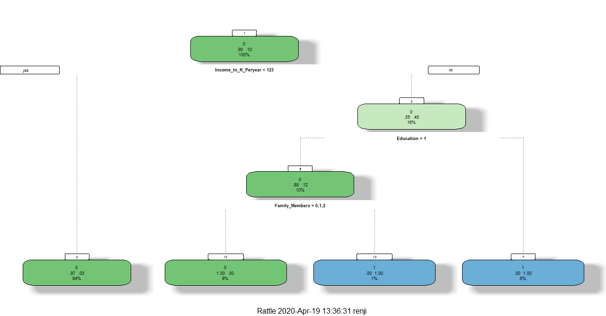

Please refer Appendix A for Source Code.

3.5 Applying Random Forest
Random forest is a classification algorithm that consists of a large number of individual decision trees that operate as an ensemble. Each individual tree in the random forest spits out a class prediction and the class with the most votes becomes our model’s prediction.A large number of relatively uncorrelated models (trees) operating as a committee will outperform any of the individual constituent models.

Like for CART, in Random Forest we will be splitting our data into train and test with a split of 70:30 and first train our model with 70 percentage of the data set and finally test it with remaining 30 percentage. These calculations are included in the model performance section.WE use the library - randomForest for performing the analysis.

The Out of bag error (OOB) is the percentage of samples tases are left out of the bootstrap sample and not used in the construction of the kth tree.Error estimated on that samples are termed as Out of Bag errors.

Initially we performed the RF analysis with train data which has a total of 3500 observations(70% of the data).The parameters used for initial run are -
Ntree- The number of trees in the model=300,
mtry=- The number of variables selected at random =10,
Nodesize- The minimum number of observations in the terminal node=50,
Importance- It help us to understand the importance of the variables=TRUE

Random Forest with Ntree = 300
> Rforest = randomForest(Personal_Loan~.,data=RFtrain,ntree=300,mtry=10,nodesize=50,importance=TRUE)
> print(Rforest)
Call:
randomForest(formula = Personal_Loan ~ ., data = RFtrain, ntree = 300, mtry = 10, nodesize = 50, importance = TRUE)
Type of random forest: classification
Number of trees: 300
No. of variables tried at each split: 10

OOB estimate of error rate: 1.74%
Confusion matrix:
0 1 class.error
0 3148 16 0.00505689
1 45 291 0.13392857

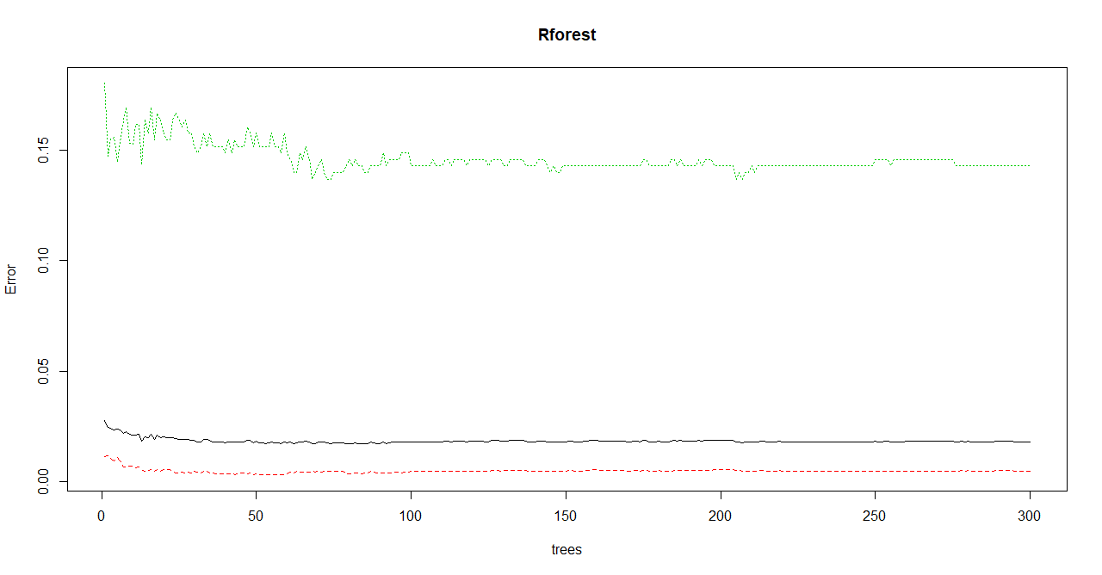
Random Forest with ntree = 100 mtry=10 and nodesize=40
Rforest2 = randomForest(Personal_Loan~.,data=RFtrain,ntree=100,mtry=10,nodesize=40,importance=TRUE)
> print(Rforest2)
Call:
randomForest(formula = Personal_Loan ~ ., data = RFtrain, ntree = 100, mtry = 10, nodesize = 40, importance = TRUE)
Type of random forest: classification
Number of trees: 100
No. of variables tried at each split: 10

OOB estimate of error rate: 1.71%
Confusion matrix:
0 1 class.error
0 3147 17 0.005372946
1 43 293 0.127976190

Tuned Random Forest Output

tRforest = tuneRF(x=RFtrain[,-c(9)],y=RFtrain$Personal_Loan,mtrystart = 10,stepfactor=1.5,ntree=100,improve=0.0001,+ nodesize=10,trace=TRUE,plot=TRUE,doBest=TRUE,importance=TRUE)
+ nodesize=10,trace=TRUE,plot=TRUE,doBest=TRUE,importance=TRUE)mtry = 3 OOB error = 1.51%
Searching left ...
mtry = 2 OOB error = 2.46%
-0.6226415 1e-04
Searching right ...
mtry = 6 OOB error = 1.4%
0.0754717 1e-04
mtry = 12 OOB error = 1.54%
-0.1020408 1e-04

Arriving at Optimal mtry
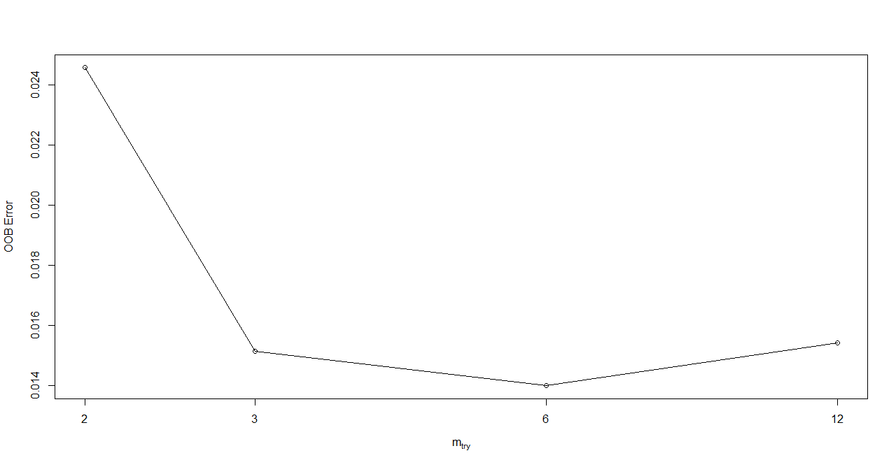

Refined RF Model with mtry=6
Rforest3 = randomForest(Personal_Loan~.,data=RFtrain,ntree=100,mtry=6,nodesize=10,importance=TRUE)> print(Rforest3)
Call:
randomForest(formula = Personal_Loan ~ ., data = RFtrain, ntree = 100, mtry = 6, nodesize = 10, importance = TRUE)
Type of random forest: classification
Number of trees: 100
No. of variables tried at each split: 6

OOB estimate of error rate: 1.51%
Confusion matrix:
0 1 class.error
0 3152 12 0.003792668
1 41 295 0.122023810

> importance(Rforest3) 0 1 MeanDecreaseAccuracy MeanDecreaseGini
Age 7.6541805 1.0431291 7.2600895 10.8299301
Experience_In_Years 6.4589848 -1.1193192 6.0467210 8.5558308
Income_In_K_Peryear 79.9740771 45.3345972 84.9312535 182.3976464
ZIP_Code 0.1862660 0.8220023 0.6983386 8.5288965
Family_Members 64.6508670 25.5152832 61.9750761 87.6080007
CCAvg 14.2843950 16.6129583 16.9375953 73.7099278
Education 87.6705046 44.2630762 92.1381679 162.0706539
Mortgage 1.6405497 -1.0450324 1.3030057 5.8808294
Securities_Account 0.2689474 -1.9859157 -1.9318647 0.6664768
CD_Account 4.2878235 2.3967410 4.8170043 19.0519544
Online -0.8055355 0.6741229 -0.1902216 0.6138092
CreditCard 2.7442633 -1.9228500 2.4515536 1.6053939

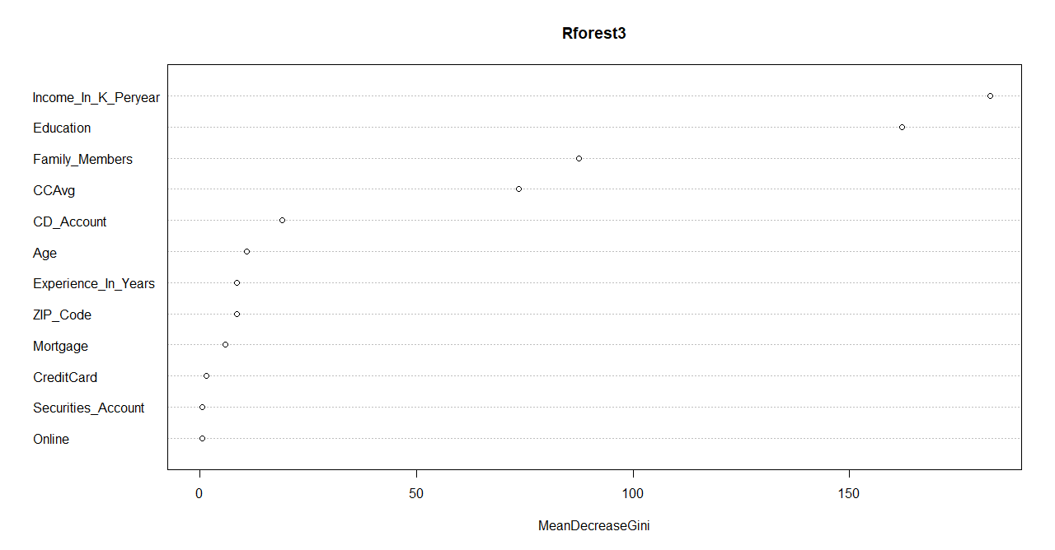

3.5.1 Interpret the RF model output

We ran the Random Forest model first with a predefined set of parameters and we chose ntree=300 and nodesize=50 and mtry=10. But after checking the tree Vs error plot, we came to a conclusion that the error remain constant after a tree size of around 100, so we changed this parameter and ran the algorithm again. We noticed that the OOB error rate was slightly reduced with less number of trees(1.74% to 1.71%). After that we did a tuned RFmodel by varying the parameters and we got the best OOB rate for the settings - ntree=100 and nodesize=10. Also from the tuned output, we arrived at the optimal mtry=6 which gave the smallest OOB error- 1.51%. Now we did a refined RF model with mtry=6 and got the output for important variables. We see that as per MeanDecreaseAccuracy the most important variables are - 1) Education, 2) Income_In_K_Peryear and 3) Family_Members and as per MeanDecreaseGini, the critical variables are Income_In_K_Peryear, Education and Family_Members in the order mentioned.

The details of model performance will be covered in the subsequent section.

Please refer Appendix A for Source Code.
3.6 Confusion Matrix
A confusion matrix is a summary of prediction results on a classification problem. The number of correct and incorrect predictions are summarized with count values and broken down by each class. The confusion matrix shows the ways in which your classification model is confused when it makes predictions. It gives us insight not only into the errors being made by a classifier but more importantly the types of errors that are being made. Below are the parameters that we are calculating from the confusion matrix -

true positives (TP): These are cases in which we predicted yes and they the actual is also yes.
true negatives (TN): We predicted no, and the actual is also no.
false positives (FP): We predicted yes, but the actual is no. (Also known as a "Type I error")
false negatives (FN): We predicted no, but they are actually yes (Also known as a "Type II error")

Accuracy: Overall, how often is the classifier correct?
Misclassification Rate: Overall, how often is it wrong?
Specificity/True Negative Rate: When it's actually no, how often does it predict no?
Recall/Sensitivity/True Positive Rate:When it's actually yes, how often does it predict yes?
Precision: When it predicts yes, how often is it correct?

CART Train -
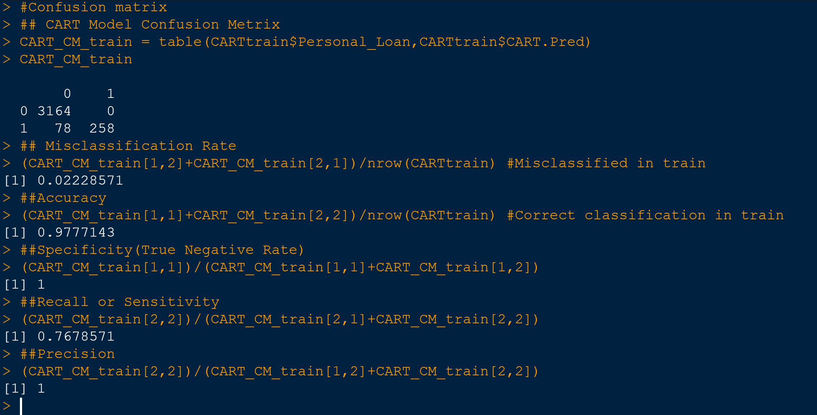

CART Test -

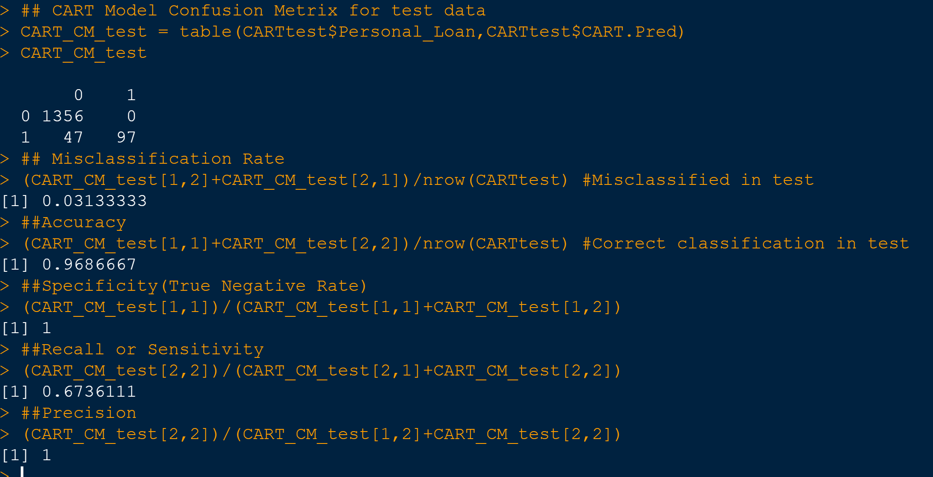

RF Train -

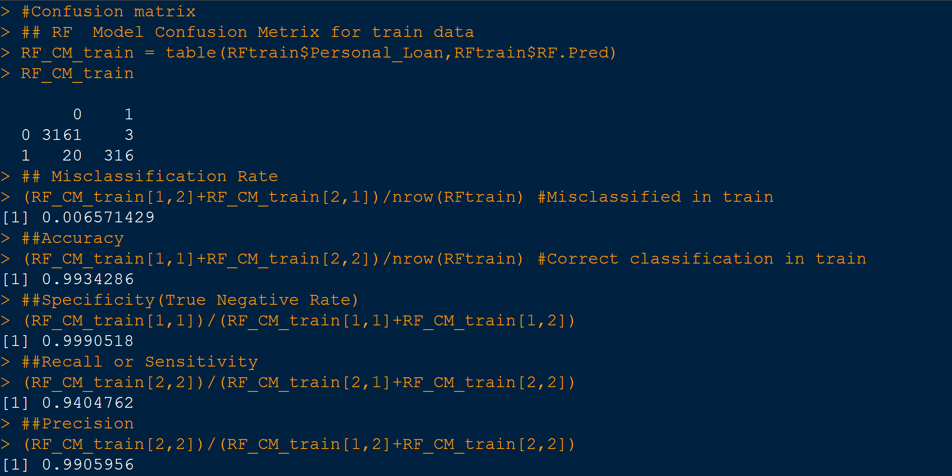

RF Test -

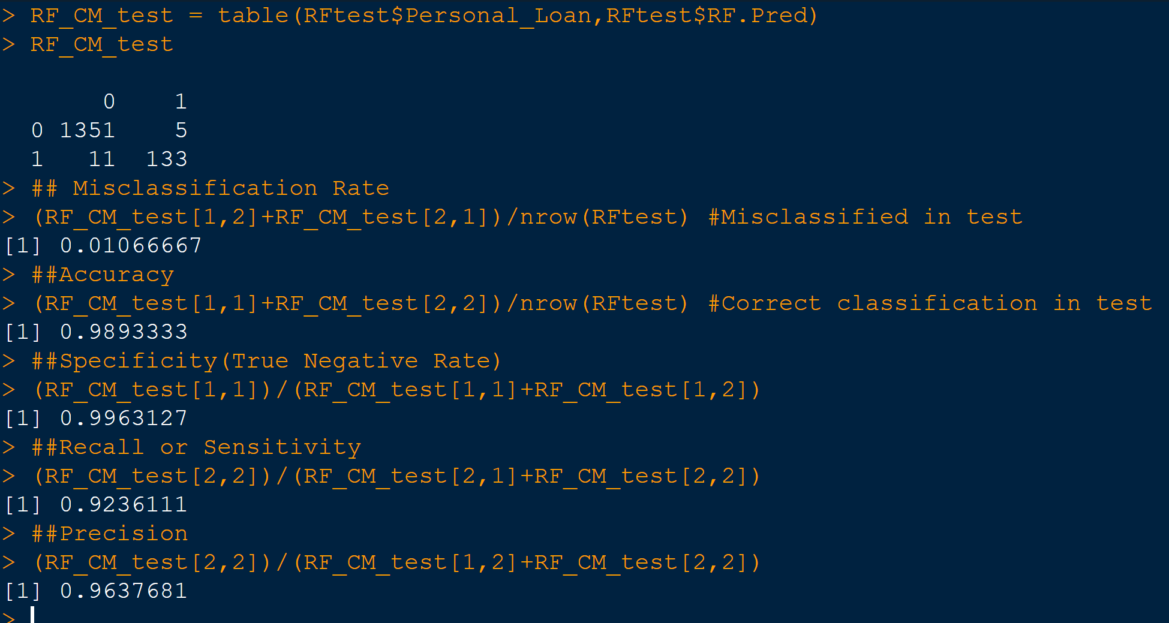

3.6.1 Confusion Matrix Interpretation-
Confusion Matrix | CART |  | RandomForest
Confusion Matrix | Train | Test | Train | Test
Misclassification Rate | 0.022 | 0.031 | 0.0065 | 0.010
Accuracy | 0.977 | 0.968 | 0.9934 | 0.989
Specificity | 1 | 1 | 0.999 | 0.996
Recall/Sensitivity | 0.768 | 0.674 | 0.940 | 0.923
Precision | 1 | 1 | 1 | 0.963

After performing the Confusion matrix, we see that the accuracy and missclassification rates are much better for RF model when compared to CART model and among the RF, the train data is slighly giving better results than test data. And as far as precision goes, we see tha all our model performed at 100%. Also we notice that the Recall/Sensitivity is much better for RF compared to CART. Looking at overall results we would advocate to proceed with RF model for our analysis instead of CART

3.7 Model Performance Measures -AUC, ROC

We use a number of model performance measures to assess the performance of the models. As a part of this analysis, we create a decile by grouping the items into 10 equal groups based on the probablity category they belong to.

Some of these measures used for Thera dataset are below -
- ROC Curve/AUC - As the threshold changes, a plot of the false positive rate vs true positive rate is called the ROC curve -Receiver Operating Characteristic. Area under the curve (AUC) is a measure of how good the model is predicting the data.It explains the trade-off between true positive rate (Sensitivity) and false positive rate (1-Specificity)
- KS (Kolmogorov-Smirnov) statistic - KS Test measures to check whether model is able to separate events and non-events. In probability of default (bank defaulters) model, it checks whether the model is able to distinguish between customers who will/will not take loan. The calculation of KS test is explained below -KS = Maximum difference between Cumulative % Event and Cumulative Non-Event
- Concordance- Create all pairs such that one record is Right & other is Wrong.It is primarily used to access the model’s predictive power
- Gini Index - The Gini index measures the extent to which the distribution of data deviates from a perfectly equal distribution. A Gini index of zero represents perfect equality and 100 for perfect inequality
- Rank/Gain at a given decile level is the ratio of cumulative number of targets (events) up to that decile to the total number of targets (events) in the entire data set.
- Lift Chart- The x-axis shows the percentile and the y-axis shows lift cumulative. Not that the default (no model), is a horizontal line intersecting the y-axis at 1. If we contact a random 10% of the population using no model, we should get 10% of the at-risk customers by default (or lift=1).

For CART Train

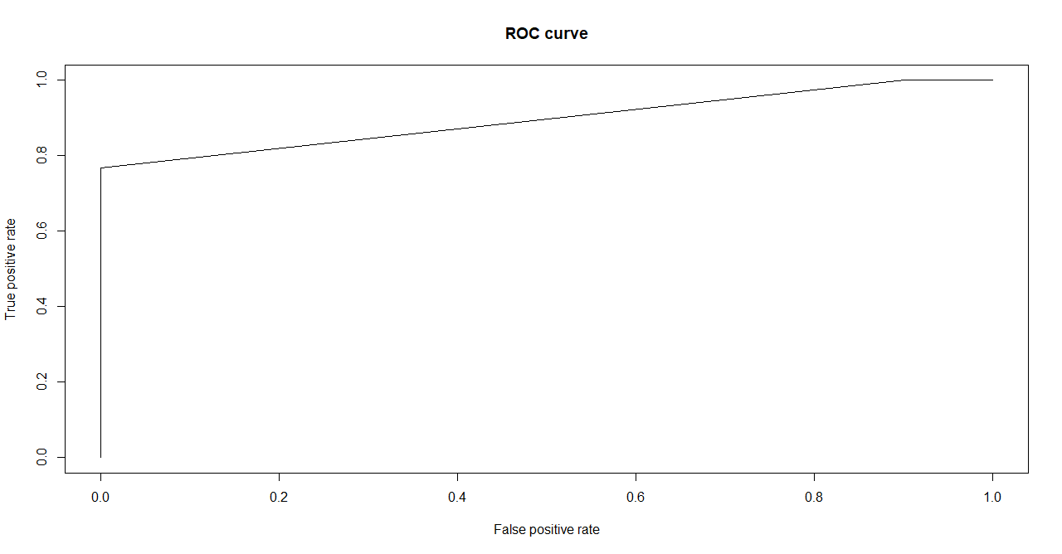
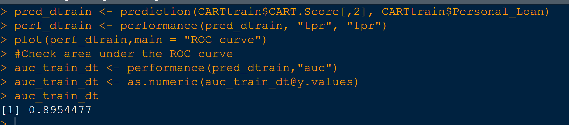

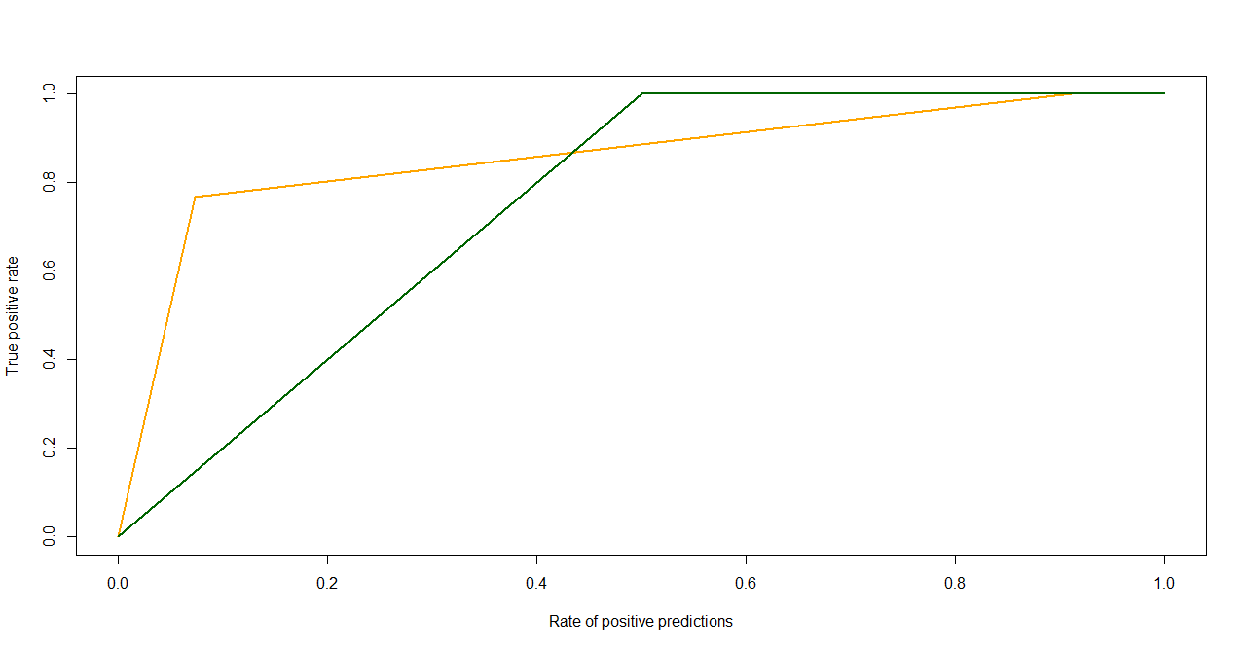
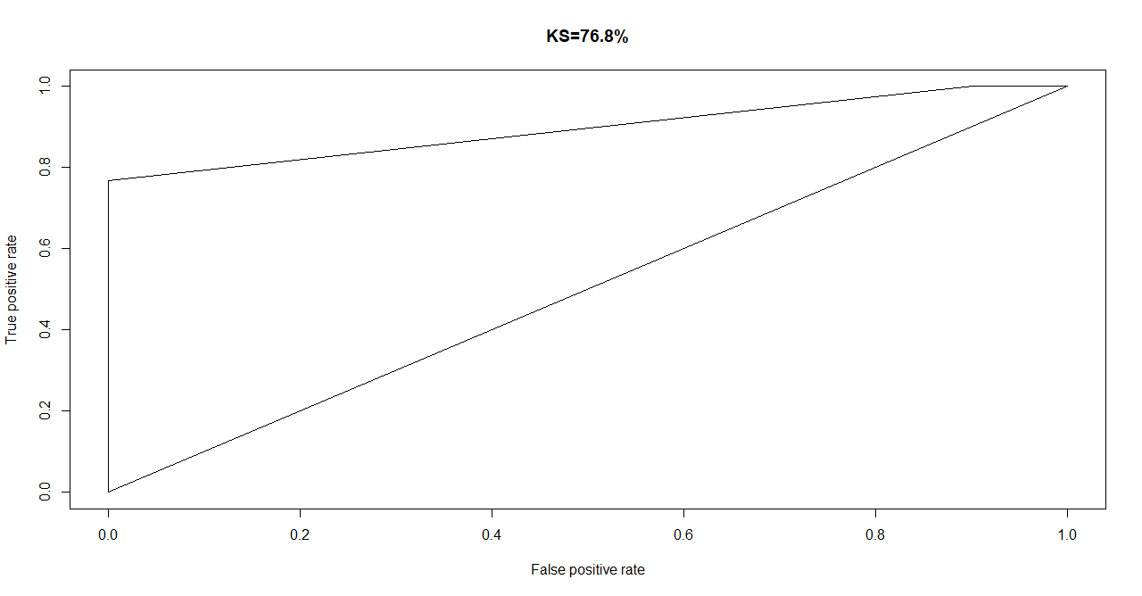

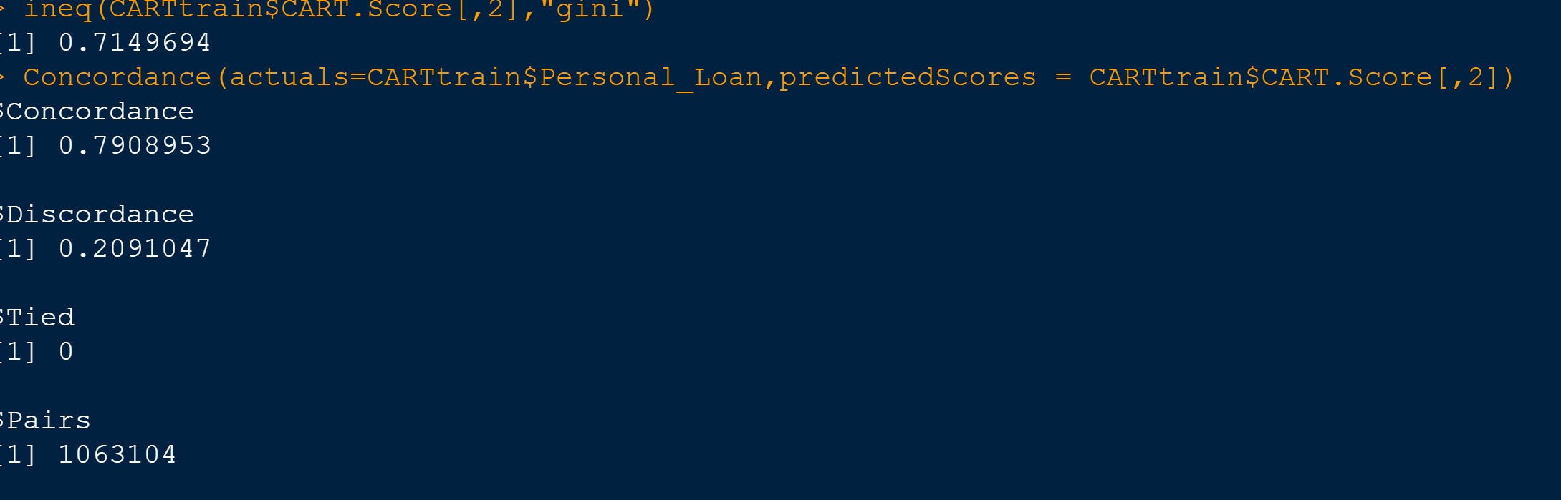
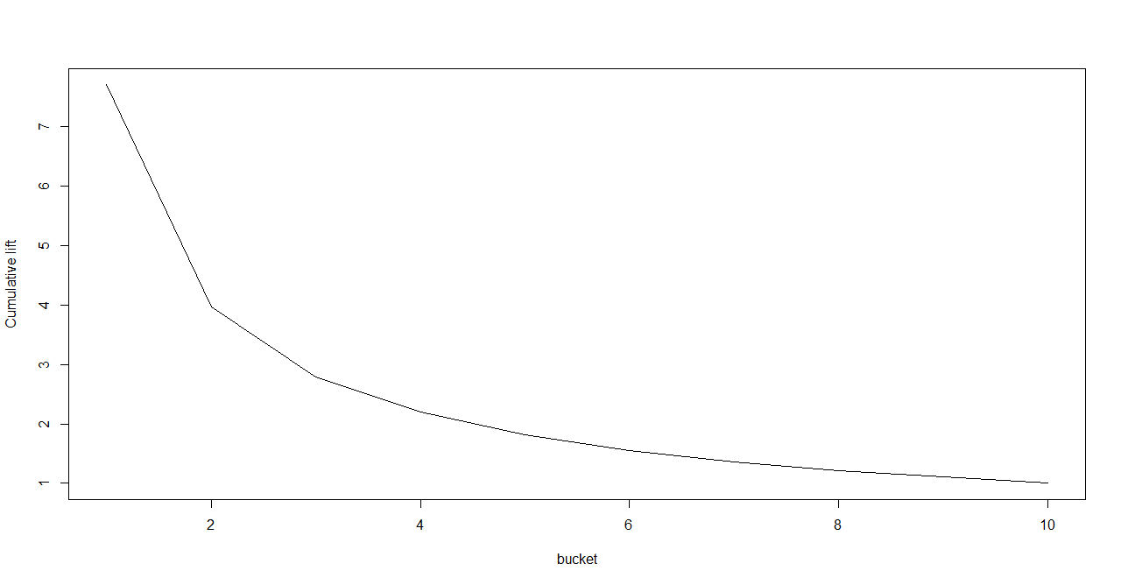

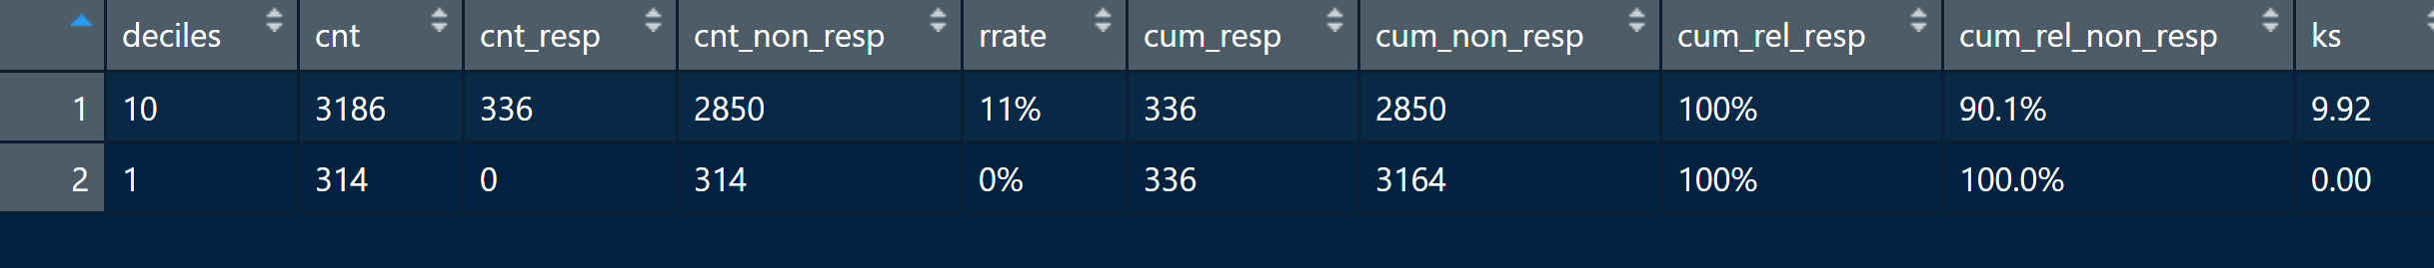

CART - Test

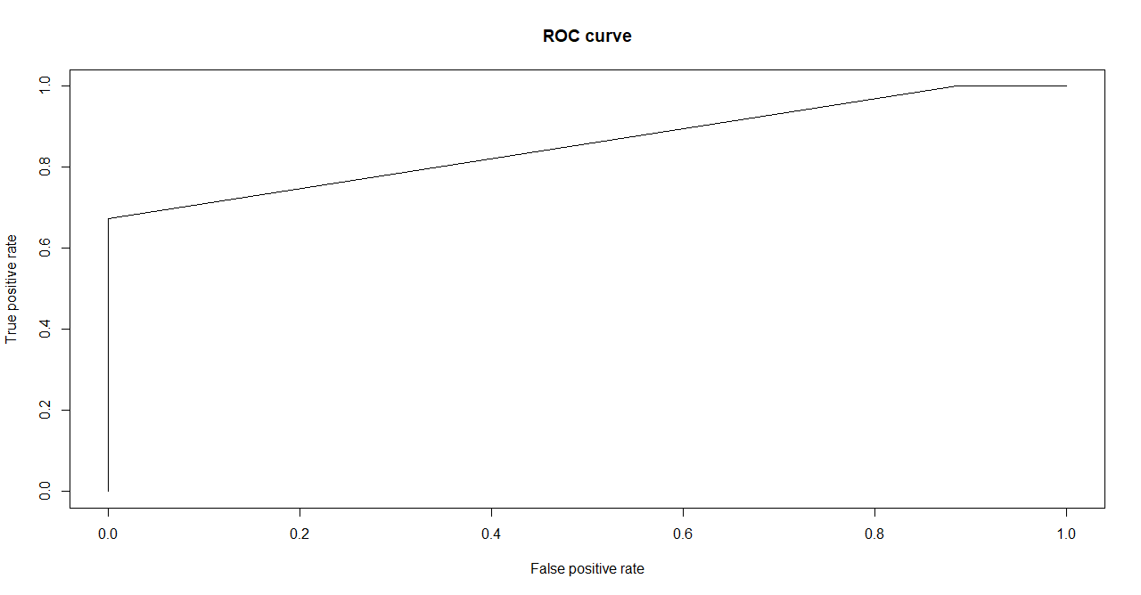
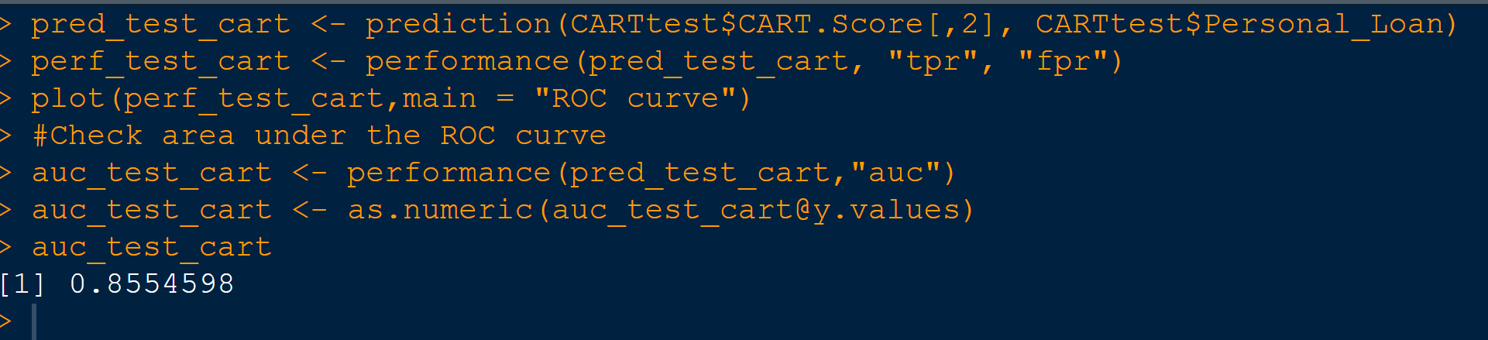

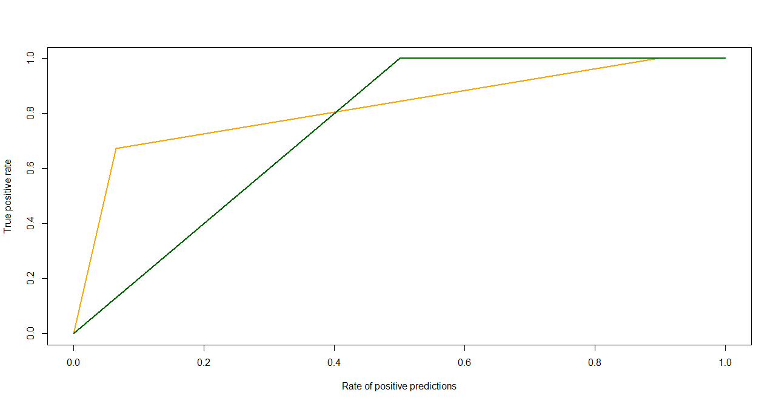

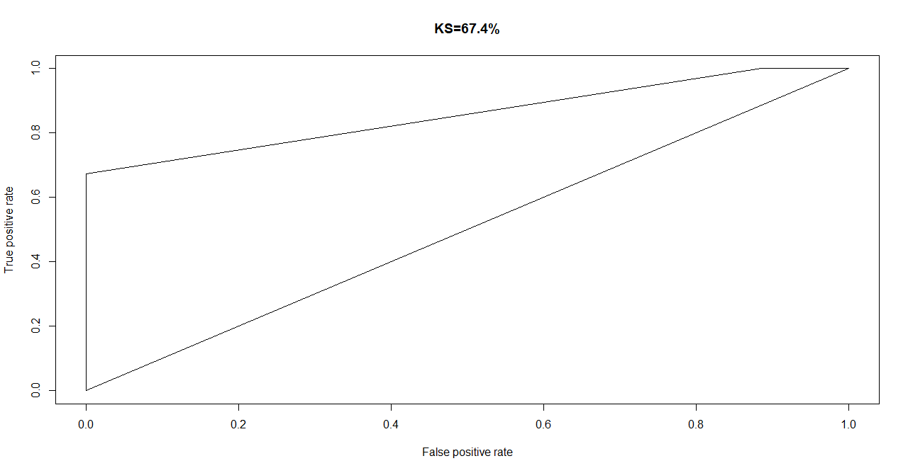

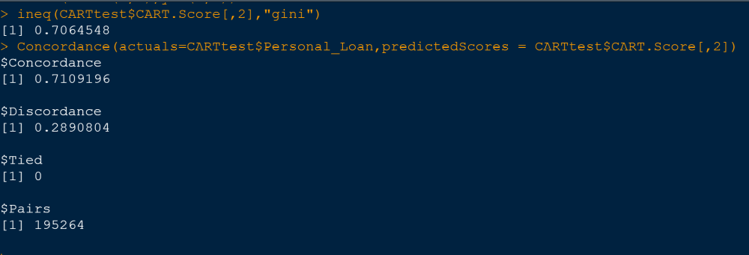

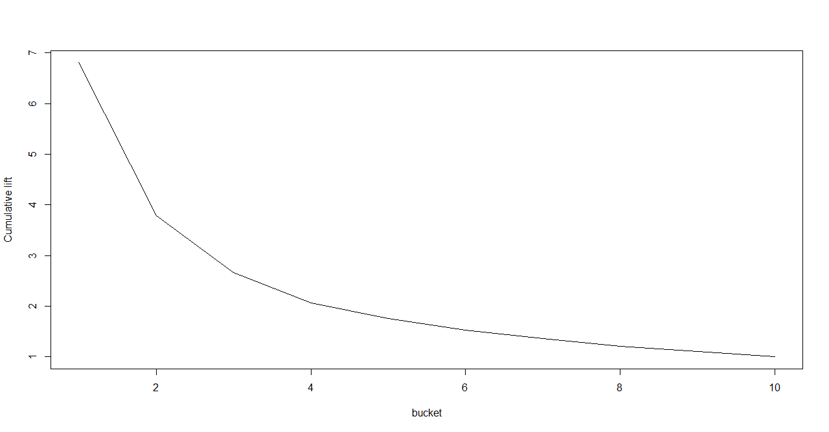
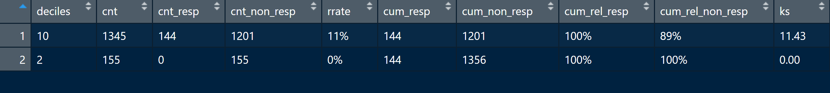

RF - Train

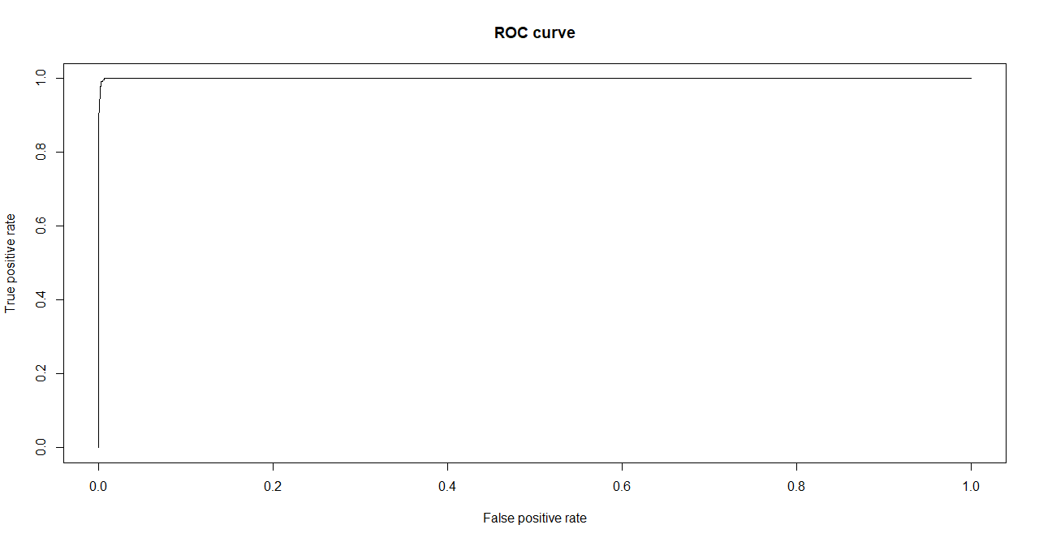
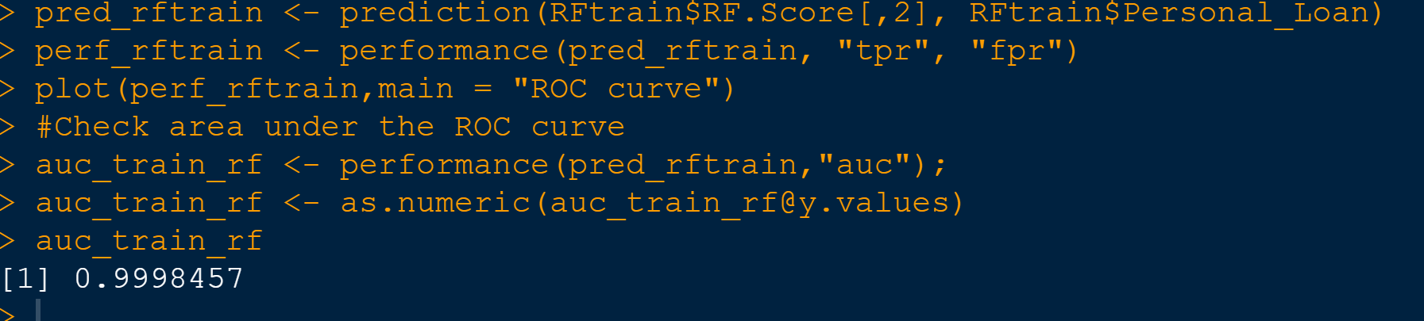

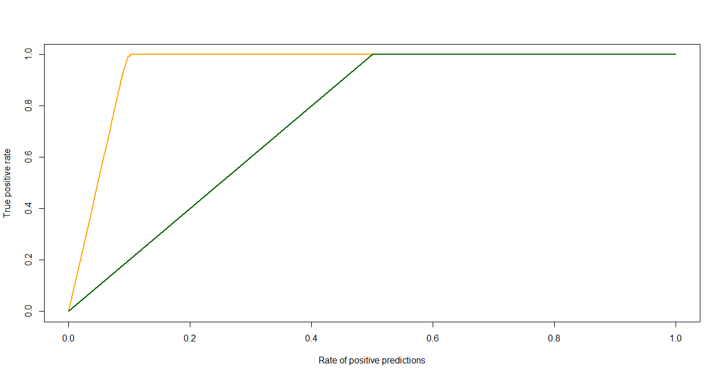
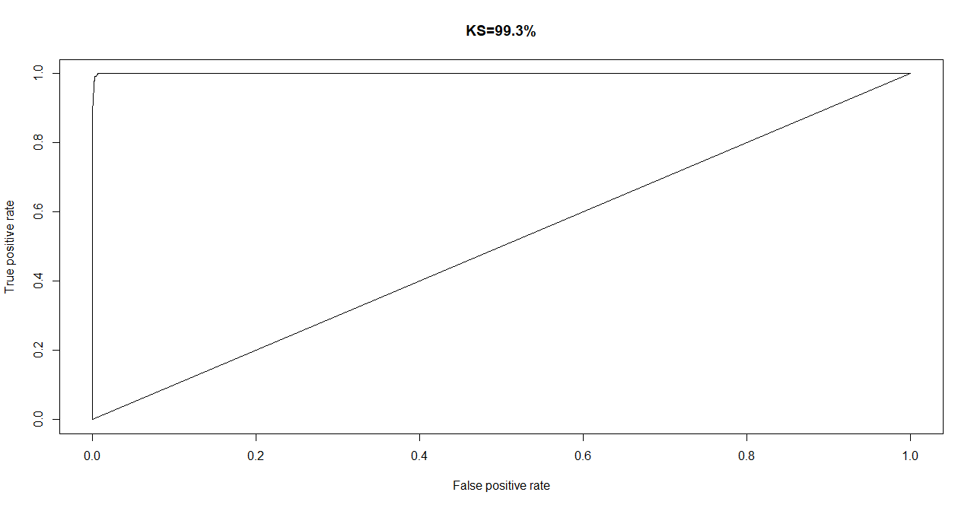

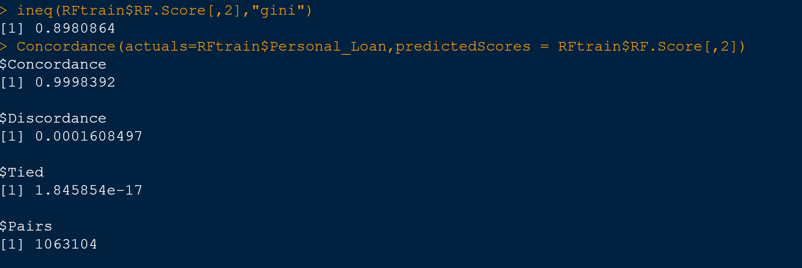

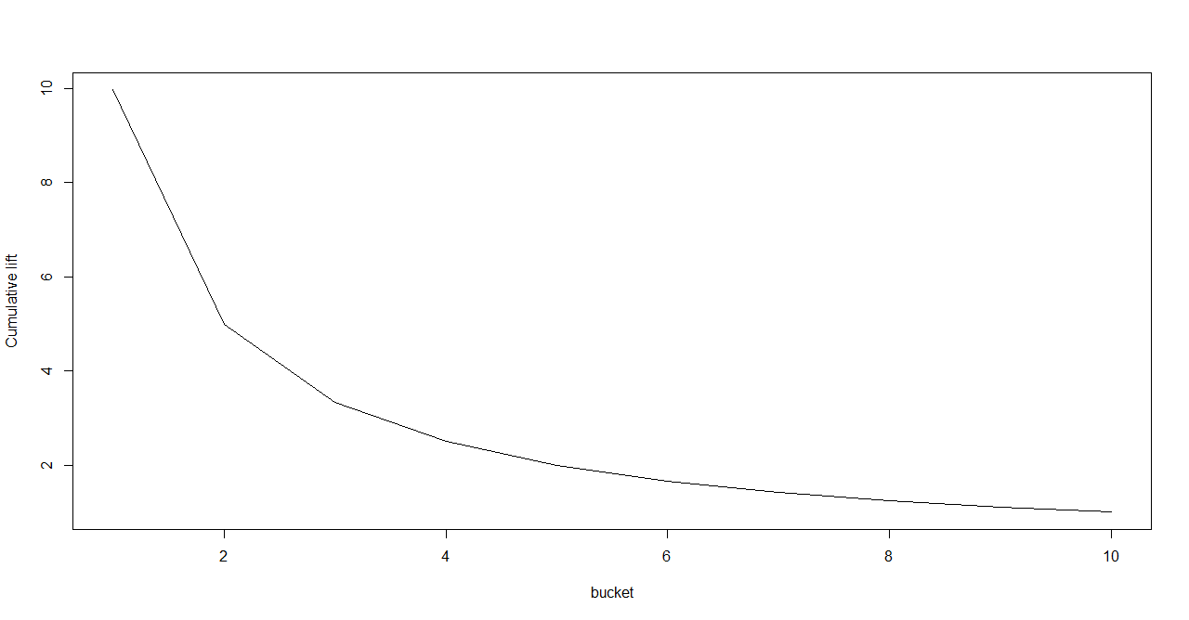

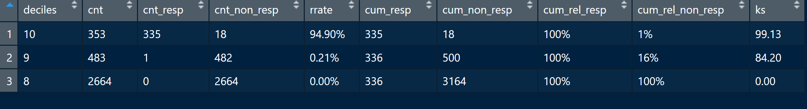

RF-Test

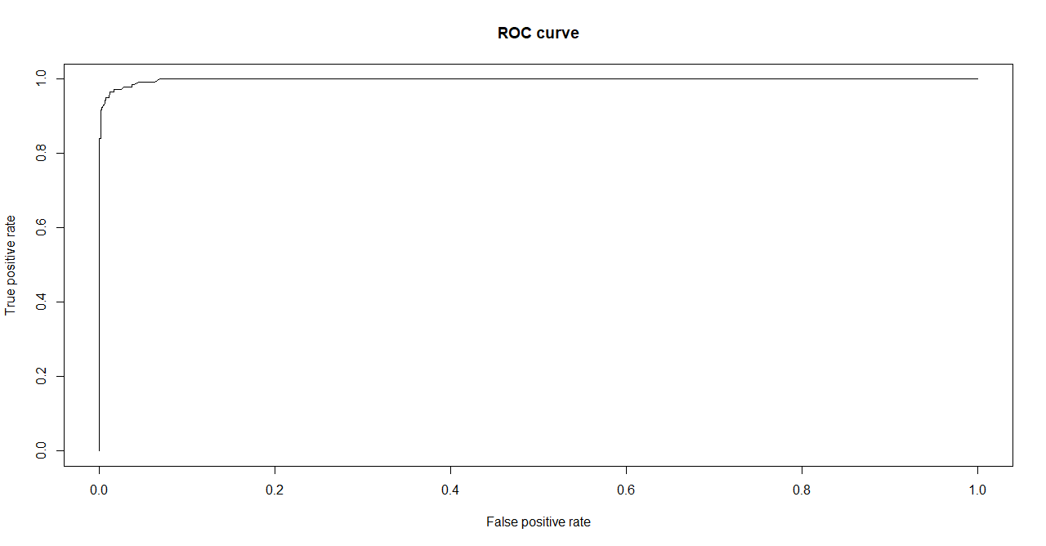

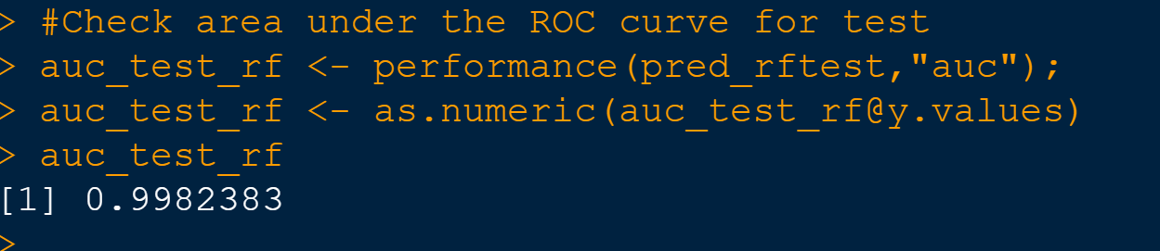

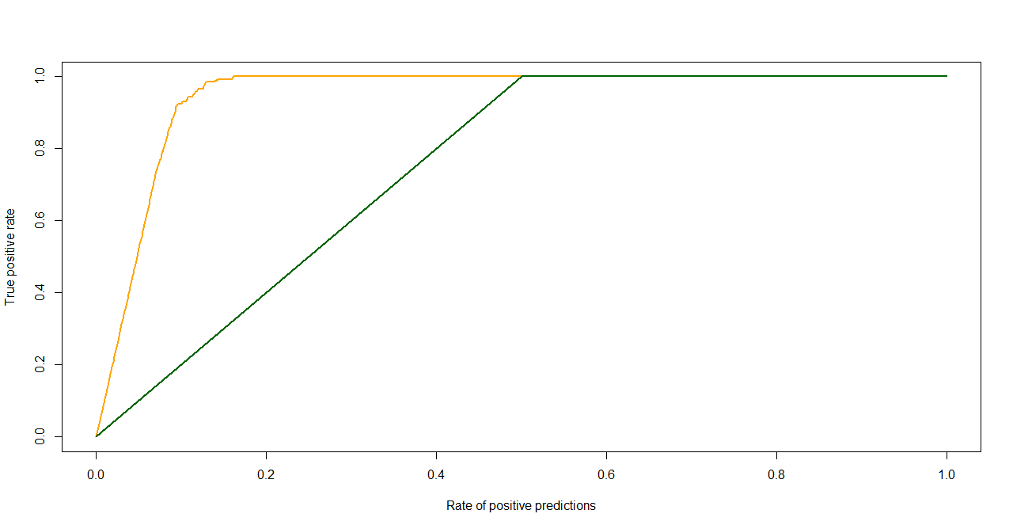
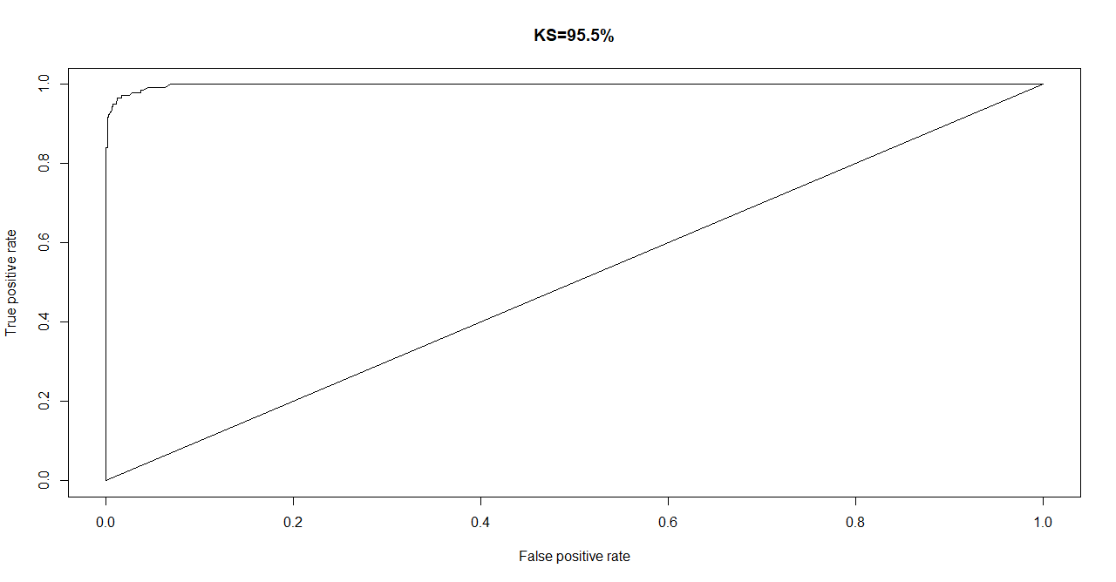

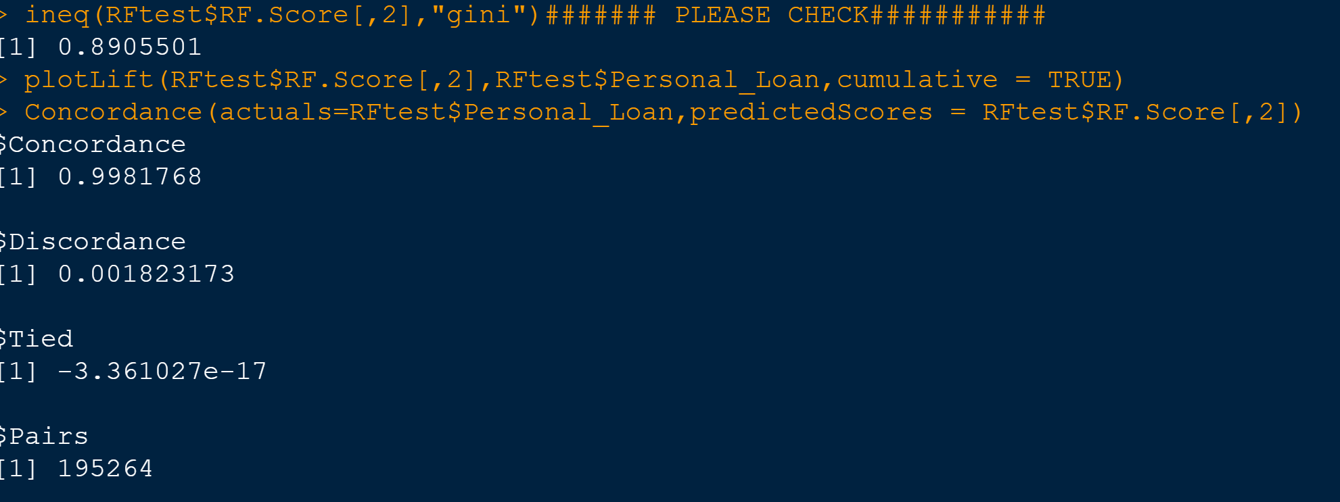

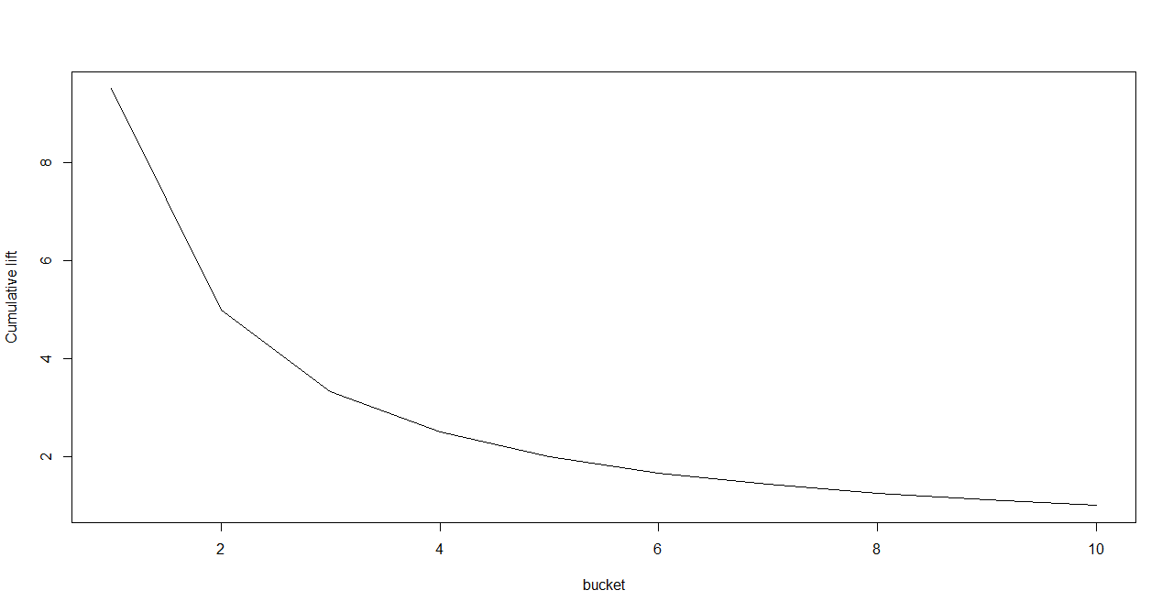

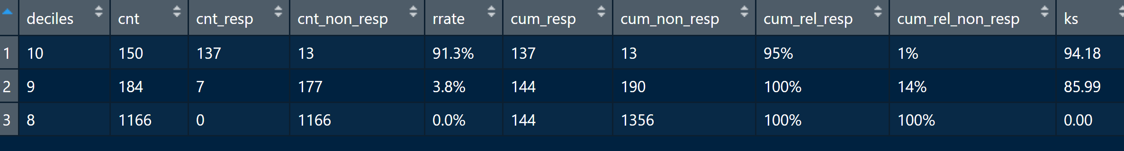

3.7.1 Interpretation of other Model Performance Measures -AUC, ROC

Model Performance | CART |  | RandomForest
Model Performance | Train | Test | Train | Test
AUC | 0.895 | 0.8554 | 0.999 | 0.998
KS Statistic | 76.8 | 67.4 | 99.3 | 95.5
Gini Index | 0.715 | 0.706 | 0.898 | 0.890
Concordance | 0.790 | 0.711 | 0.999 | 0.998
Lift For 10 percentile | 7 | 6.5 | 9.8 | 9.5

Looking at the outputs from Model performance, we see that the Area Under the Curve is good for both models ( AUC > 70), but the RF model outperforms the CART model.While checking the KS statistic we see that for both models, it is in the top 3 deciles (70%), however the RF model has a much higher value than CART.As far as Gini Index is concerned, the values are higher for RF model compared to CART, which means that there is big gap among the persons who will apply for a loan and so we must target those high percentil customers.Coming to Concordance, the higher value indicates a better model ad in our case RF prove to be much better than CART. Finally analyzing the lift chat, for 10th percentile, we get a cumulative lift of 6.5-7 for CART and 9.5-9.8 for RF. This means that our model should be able to capture about 65-70% for CART and 95-98% for RF - Loan customers if we were to reach out to top 10 percentile of the customers as in the model, ie our model can help us increase the prediction of the Loan customers by a factor between 6.5 to 9.8. As expected here also RF outperforms CART model.

Please refer Appendix A for Source Code.

3.8 Remarks on Model validation exercise <Which model performed the best>

As mentioned above, we performed model analysis with both models - CART & RF for each of the Train & test data sets and compared the results. We did this by segregating the data into train and test with 70:30 split and analyzing performance from each category.From a model perspective, it was very clear that the Random Forest Performed much better than CART. And again among the RF model, the train data set was much better than test data set which is kind of expected as it is a new dataset on which the model was applied. The same trend was noted for CART as well. The RF model was a clear winner in terms of Confusion matrix coefficients such as Accuracy, Specificity etc and also for model performance measures such as Gini Index, KS statistic, AUC etc. Overall we can say that both models performance was satisfactory, but RF was much better performer and we would opt Random Forest over CART

3.9 Appendix A:

install.packages("readxl")
install.packages("dplyr")
install.packages("ggplot2")
install.packages("DataExplorer")
install.packages("corrplot")
install.packages("caTools")
install.packages("rpart")
install.packages("ROCR")
install.packages("rattle")
install.packages("data.tables")
install.packages("scales")
install.packages("InformationValue")
install.packages("ineq")

library(dplyr)
library(DataExplorer)
library(ggplot2)
library(readxl)
library(corrplot)
library(caTools)
library(rpart)
library(rpart.plot)
library(rattle)
library(ROCR)
library(data.tables)
library(scales)
library(InformationValue)
library(ineq)

# Set the working directory and check it
setwd("C:/2020/RProgramming/DataMining")
getwd()

#Import the data
Thera_Bank <- read_excel("C:/2020/RProgramming/DataMining/Thera Bank_dataset.xlsx", sheet=2)
View(Thera_Bank)

##Check the dimension or shape of the data
dim(Thera_Bank)

#Perform basic summary
head(Thera_Bank)
tail(Thera_Bank)

##View top 5 rows
Thera_Bank[1:5,]

##Lets see the variable list in the data and then make changes to the col names
names(Thera_Bank)
names(Thera_Bank)[names(Thera_Bank)== "Age (in years)"] <- "Age"
names(Thera_Bank)[names(Thera_Bank)== "Experience (in years)"] <- "Experience_In_Years"
names(Thera_Bank)[names(Thera_Bank)== "Income (in K/year)"] <- "Income_In_K_Peryear"
names(Thera_Bank)[names(Thera_Bank)== "ZIP Code"] <- "ZIP_Code"
names(Thera_Bank)[names(Thera_Bank)== "Family members"] <- "Family_Members"
names(Thera_Bank)[names(Thera_Bank)== "Personal Loan"] <- "Personal_Loan"
names(Thera_Bank)[names(Thera_Bank)== "Securities Account"] <- "Securities_Account"
names(Thera_Bank)[names(Thera_Bank)== "CD Account"] <- "CD_Account"

names(Thera_Bank)

##Lets see the datatype of the data set. Can see several factor variables as factors
str(Thera_Bank)
summary(Thera_Bank)
Thera_Bank$Experience_In_Years = abs(Thera_Bank$Experience_In_Years)
sum(is.na(Thera_Bank))
#Replacing NA values in the dataset with zeroes
Thera_Bank[is.na(Thera_Bank)] = 0
any(is.na(Thera_Bank))

##Convert all variables into factors where necessary.
#library(dplyr)
Thera_Bank$Personal_Loan <- as.factor(Thera_Bank$Personal_Loan)
Thera_Bank$Securities_Account <- as.factor(Thera_Bank$Securities_Account)
Thera_Bank$CD_Account <- as.factor(Thera_Bank$CD_Account)
Thera_Bank$Online <- as.factor(Thera_Bank$Online)
Thera_Bank$CreditCard <- as.factor(Thera_Bank$CreditCard)
Thera_Bank$Family_Members <- as.factor(Thera_Bank$Family_Members)
# For education, we convert it into an Ordered factor such that 1 < 2 < 3
Thera_Bank$Education <- factor(Thera_Bank$Education,levels=c('1','2','3'),ordered = TRUE)

str(Thera_Bank)

##Summary Statistics Measure of central tendency and dispersion (Univariate Analysis)

summary(Thera_Bank)
##(count,missing value,mean,0.01,0.05,0.10,0.25,Median,0.75,0.90,0.95,0.99,min,max,range,skew,kurtosis,
#SD,IQR) for continous variable

names(Thera_Bank)
boxplot(Thera_Bank$Income_In_K_Peryear)
boxplot(Thera_Bank$CCAvg)
boxplot(Thera_Bank$Mortgage)

boxplot.stats(Thera_Bank$Income_In_K_Peryear)$out
summary(Thera_Bank$Income_In_K_Peryear)

#For missing values that lie outside the 1.5 * IQR limits, we could cap it by replacing those observations outside the lower limit with the value of 5th %ile and those that lie
#above the upper limit, with the value of 95th %ile. Below is a sample code that achieves this.
#Thera_Bank$Income_In_K_Peryear <- Thera_Bank$Income_In_K_Peryear

##Outlier Treatment for Income_In_K_Peryear variable
boxplot(Thera_Bank$Income_In_K_Peryear)
qnt <- quantile(Thera_Bank$Income_In_K_Peryear, probs=c(.25, .75), na.rm = T)
caps <- quantile(Thera_Bank$Income_In_K_Peryear, probs=c(.05, .95), na.rm = T)
H <- 1.5 * IQR(Thera_Bank$Income_In_K_Peryear, na.rm = T)
Thera_Bank$Income_In_K_Peryear[Thera_Bank$Income_In_K_Peryear < (qnt[1] - H)] <- caps[1]
Thera_Bank$Income_In_K_Peryear[Thera_Bank$Income_In_K_Peryear > (qnt[2] + H)] <- caps[2]

summary(Thera_Bank$Income_In_K_Peryear)
boxplot(Thera_Bank$Income_In_K_Peryear)
boxplot.stats(Thera_Bank$Income_In_K_Peryear)$out

## Outlier Treatment for CCAvg variable
qnt <- quantile(Thera_Bank$CCAvg, probs=c(.25, .75), na.rm = T)
caps <- quantile(Thera_Bank$CCAvg, probs=c(.05, .95), na.rm = T)
H <- 1.5 * IQR(Thera_Bank$CCAvg, na.rm = T)
Thera_Bank$CCAvg[Thera_Bank$CCAvg < (qnt[1] - H)] <- caps[1]
Thera_Bank$CCAvg[Thera_Bank$CCAvg > (qnt[2] + H)] <- caps[2]

summary(Thera_Bank$CCAvg)
boxplot(Thera_Bank$CCAvg)
boxplot.stats(Thera_Bank$CCAvg)$out
names(Thera_Bank)

## Outlier Treatment for Mortgage variable
qnt <- quantile(Thera_Bank$Mortgage, probs=c(.25, .75), na.rm = T)
caps <- quantile(Thera_Bank$Mortgage, probs=c(.05, .95), na.rm = T)
H <- 1.5 * IQR(Thera_Bank$Mortgage, na.rm = T)
Thera_Bank$Mortgage[Thera_Bank$Mortgage < (qnt[1] - H)] <- caps[1]
Thera_Bank$Mortgage[Thera_Bank$Mortgage > (qnt[2] + H)] <- caps[2]

summary(Thera_Bank$Mortgage)
str(Thera_Bank)
boxplot(Thera_Bank$Mortgage)
boxplot.stats(Thera_Bank$Mortgage)$out

# Checking the Summary and Structure of dataset after making doing the treatments
summary(Thera_Bank)
str(Thera_Bank)

#Thera_Bank_Cat_Var = Thera_Bank[c(5,6,8:14)]
#Thera_Bank_Cont_Var = Thera_Bank[c(2,3,4,7)]
#Thera_Bank_Cat_Var
#Thera_Bank_Cont_Var

## Univariate Analysis

plot_intro(Thera_Bank)
plot_histogram(Thera_Bank)
plot_bar(Thera_Bank, title="Categorical variables")
## Bivariate Analysis

#Boxplots
plot_boxplot(Thera_Bank, by = "Education", geom_boxplot_args = list("outlier.color" = "blue"))
plot_boxplot(Thera_Bank, by = "Personal_Loan", geom_boxplot_args = list("outlier.color" = "blue"))
plot_boxplot(Thera_Bank, by = "Family_Members", geom_boxplot_args = list("outlier.color" = "blue"))

ggplot(Thera_Bank, aes(Age, fill= Personal_Loan)) + geom_density(alpha=0.5)
ggplot(Thera_Bank, aes(Experience_In_Years, fill= Personal_Loan)) + geom_density(alpha=0.5)
ggplot(Thera_Bank, aes(Income_In_K_Peryear, fill= Personal_Loan)) + geom_density(alpha=0.5)
ggplot(Thera_Bank, aes(CCAvg, fill= Personal_Loan)) + geom_density(alpha=0.5)
ggplot(Thera_Bank, aes(Mortgage, fill= Personal_Loan)) + geom_density(alpha=0.5)

ggplot(Thera_Bank, aes(Income_In_K_Peryear, Mortgage, color = Personal_Loan)) + geom_point(alpha = 0.5)
ggplot(Thera_Bank, aes(Income_In_K_Peryear, CCAvg, color = Personal_Loan)) + geom_point(alpha = 0.5)
ggplot(Thera_Bank, aes(CCAvg, Mortgage, color = Personal_Loan)) + geom_point(alpha = 0.5)

counts <- table(Thera_Bank$Family_Members,Thera_Bank$Personal_Loan)
counts
barplot(counts, main="Family members vs Personal Loan",
xlab="Personal Loan No vs Yes",ylab="No: of Observations", col=c("darkblue","red","green","yellow","black"),
legend = rownames(counts), beside=TRUE)

counts <- table(Thera_Bank$Education,Thera_Bank$Personal_Loan)
counts
barplot(counts, main="Education vs Personal Loan",
xlab="Personal Loan No vs Yes",ylab="No: of Observations", col=c("darkblue","red","green"),
legend = rownames(counts), beside=TRUE)
##################################################################################################
##correlation between continous variables (Multi variate Analysis)
plot_correlation(Thera_Bank[,c(2,4,5,7,9)])
##correlation between categorical variables
cor(Thera_Bank[,c(3,6,8,10,11,12,13,14)])
#corrplot(Thera_Bank[c(2,3,4,7,9)],method="number")

#********************************************************
summary(Thera_Bank$Mortgage)
names(Thera_Bank)
#length(Thera_Bank$ZIP_Code)
#length(unique(Thera_Bank$ZIP_Code))

########################################################################################################################
##Build a decision tree using CART technique
########################################################################################################################

## Spliting the dataset into train and test for development and out of sample testing respectively
library(caTools)
set.seed(100)
names(Thera_Bank)
#Removing the id column
Thera_Bank = Thera_Bank[-1]
names(Thera_Bank)

#we are splitting the data such that we have 70% of the data is Train Data and 30% of the data is my Test Data
split1 <- sample.split(Thera_Bank$Personal_Loan, SplitRatio = 0.7)
View(split1)
#Use subset function to get the data that is TRUE for the training data set
CARTtrain<- subset(Thera_Bank, split1 == TRUE)
#Use subset function to get the data that is FALSE for the training data set
CARTtest<- subset(Thera_Bank, split1 == FALSE)
#Dimensions of test and train data
dim(CARTtrain)
dim(CARTtest)
#View the train and test data sets
View(CARTtrain)
View(CARTtest)
## Calculate the response rate. To see number of actual employees that have left organization.
table(CARTtrain$Personal_Loan)
sum(CARTtrain$Personal_Loan == "1")/nrow(CARTtrain)

##Import rpart and rpart.plot library for creating CART model
library(rpart)
library(rpart.plot)

#Define the parameters
#Hence, minsplit helps us avoid overfitting by pre-pruning the tree before we test our model.
r.ctrl = rpart.control(minsplit=100, minbucket = 10, cp = 0, xval = 10)

#Building the CART model using the rpart function and the pre defined parameters
m1 <- rpart(formula = Personal_Loan~., data = CARTtrain, method = "class", control = r.ctrl)
m1
#Displaying the decision tree
library(rattle)
fancyRpartPlot(m1)

#Examine the complexity plot
printcp(m1)
plotcp(m1)

#Prune the tree at cp=0.002 and view it
m1_pruned <- prune(m1, cp = 0.024)
m1_pruned
names(Thera_Bank)
#Display the new pruned tree
fancyRpartPlot(m1_pruned)

###############################################################

CARTtest$CART.Pred = predict(m1_pruned,CARTtest,type="class")
CARTtest$CART.Score = predict(m1_pruned,CARTtest,type="prob")

View(CARTtrain)
View(CARTtest)
class(CARTtrain)
class(CARTtest)
names(Thera_Bank)
########################################################################################################################
##Build a Random Forest model
########################################################################################################################

## Spliting the dataset into train and test for development and out of sample testing respectively
set.seed(100)
#we are splitting the data such that we have 70% of the data is Train Data and 30% of the data is my Test Data
split2 <- sample.split(Thera_Bank$Personal_Loan, SplitRatio = 0.7)
View(split1)
#Use subset function to get the data that is TRUE for the training data set
RFtrain<- subset(Thera_Bank, split2 == TRUE)

#Use subset function to get the data that is FALSE for the testing data set
RFtest<- subset(Thera_Bank, split2 == FALSE)

dim(RFtrain)
dim(RFtest)

##import randomForest library for building random forest model
library(randomForest)

## set a seed to start the randomness
seed = 1000
set.seed(seed)

##Build the first RF model
#Node size shall be ~2% of the population. This is similar to minbucket paraeter in CART
#0.02*3500 = 70
# mtry can be taken as sqrt(Variables) = 4

Rforest = randomForest(Personal_Loan~.,data=RFtrain,ntree=300,mtry=10,nodesize=50,importance=TRUE)

##Print the model to see the OOB and error rate
print(Rforest)

# Running RF again with ntree=101
Rforest2 = randomForest(Personal_Loan~.,data=RFtrain,ntree=100,mtry=10,nodesize=40,importance=TRUE)
##Print the model to see the OOB and error rate
print(Rforest2)
##Plot the RF to know the optimum number of trees
plot(Rforest2)

##The above plot shows - Misclassification/error rate as a function of trees grown
#The black line represents the entire sample,
#the green line represents the error rate where Y = 0
#and the red line represents the error rate when Y = 1.

View(RFtrain)
##Tune up the RF model to find out the best mtry which reduces the Out of bag error estimate
#If doBest is set as TRUE, a random forest object is returned with the optimal obtained mtry
set.seed(seed)
tRforest = tuneRF(x=RFtrain[,-c(9)],y=RFtrain$Personal_Loan,mtrystart = 10,stepfactor=1.5,ntree=100,improve=0.0001,
nodesize=10,trace=TRUE,plot=TRUE,doBest=TRUE,importance=TRUE)

##Build the refined RF model
Rforest3 = randomForest(Personal_Loan~.,data=RFtrain,ntree=100,mtry=6,nodesize=10,importance=TRUE)
print(Rforest3)
plot(tRforest)
##Identify the importance of the variables
importance(Rforest3)
varImpPlot(Rforest3,type=2)

#################################################################################################
#########################################################################################

##Use this tree to do the prediction on train as well as test data set
RFtrain$RF.Pred = predict(Rforest3,data=RFtrain,type="class")
RFtrain$RF.Score = predict(Rforest3,data=RFtrain,type="prob")

RFtest$RF.Pred = predict(Rforest3,RFtest,type="class")
RFtest$RF.Score = predict(Rforest3,RFtest,type="prob")

View(RFtrain)
View(RFtest)

########################################################################################################################
##Assess the Models Performance - CART
########################################################################################################################
## Let's use rattle to see various model evaluation measures
##rattle()
library(rattle)

## Scoring syntax for train data set
##Use this pruned tree to do the prediction on train as well as test data set
CARTtrain$CART.Pred = predict(m1_pruned,data=CARTtrain,type="class")
CARTtrain$CART.Score = predict(m1_pruned,data=CARTtrain, type="prob")

## deciling code
decile <- function(x){
deciles <- vector(length=10)
for (i in seq(0.1,1,.1)){
deciles[i*10] <- quantile(x, i, na.rm=T)
}
return (
ifelse(x<deciles[1], 1,
ifelse(x<deciles[2], 2,
ifelse(x<deciles[3], 3,
ifelse(x<deciles[4], 4,
ifelse(x<deciles[5], 5,
ifelse(x<deciles[6], 6,
ifelse(x<deciles[7], 7,
ifelse(x<deciles[8], 8,
ifelse(x<deciles[9], 9, 10
))))))))))
}
class(CARTtrain$CART.Score)
## deciling
CARTtrain$deciles <- decile(CARTtrain$CART.Score[,2])
View(CARTtrain)

## Ranking code
##install.packages("data.table")
##install.packages("scales")
library(data.table)
library(scales)
tmp_Train = data.table(CARTtrain)
rank <- tmp_Train[, list(
cnt = length(Personal_Loan),
cnt_resp = sum(Personal_Loan == 1),
cnt_non_resp = sum(Personal_Loan == 0)) ,
by=deciles][order(-deciles)]

rank$rrate <- round(rank$cnt_resp / rank$cnt,4);
rank$cum_resp <- cumsum(rank$cnt_resp)
rank$cum_non_resp <- cumsum(rank$cnt_non_resp)
rank$cum_rel_resp <- round(rank$cum_resp / sum(rank$cnt_resp),4);
rank$cum_rel_non_resp <- round(rank$cum_non_resp / sum(rank$cnt_non_resp),4);
rank$ks <- abs(rank$cum_rel_resp - rank$cum_rel_non_resp) * 100;
rank$rrate <- percent(rank$rrate)
rank$cum_rel_resp <- percent(rank$cum_rel_resp)
rank$cum_rel_non_resp <- percent(rank$cum_rel_non_resp)

View(rank)

## Scoring syntax for test data set
##Use this pruned tree to do the prediction on train as well as test data set
CARTtest$CART.Pred = predict(m1_pruned,data=CARTtest,type="class")
CARTtest$CART.Score = predict(m1_pruned,data=CARTtest, type="prob")

## deciling code

class(CARTtest$CART.Score)
## deciling
CARTtrain$deciles <- decile(CARTtrain$CART.Score[,2])
View(CARTtrain)

## Ranking code
##install.packages("data.table")
##install.packages("scales")
library(data.table)
library(scales)
tmp_Train = data.table(CARTtrain)
rank <- tmp_Train[, list(
cnt = length(Personal_Loan),
cnt_resp = sum(Personal_Loan == 1),
cnt_non_resp = sum(Personal_Loan == 0)) ,
by=deciles][order(-deciles)]

rank$rrate <- round(rank$cnt_resp / rank$cnt,4);
rank$cum_resp <- cumsum(rank$cnt_resp)
rank$cum_non_resp <- cumsum(rank$cnt_non_resp)
rank$cum_rel_resp <- round(rank$cum_resp / sum(rank$cnt_resp),4);
rank$cum_rel_non_resp <- round(rank$cum_non_resp / sum(rank$cnt_non_resp),4);
rank$ks <- abs(rank$cum_rel_resp - rank$cum_rel_non_resp) * 100;
rank$rrate <- percent(rank$rrate)
rank$cum_rel_resp <- percent(rank$cum_rel_resp)
rank$cum_rel_non_resp <- percent(rank$cum_rel_non_resp)

View(rank)

#Confusion matrix
## CART Model Confusion Metrix
CART_CM_train = table(CARTtrain$Personal_Loan,CARTtrain$CART.Pred)
CART_CM_train

## Misclassification Rate
(CART_CM_train[1,2]+CART_CM_train[2,1])/nrow(CARTtrain) #Misclassified in train

##Accuracy
(CART_CM_train[1,1]+CART_CM_train[2,2])/nrow(CARTtrain) #Correct classification in train

##Specificity(True Negative Rate)
(CART_CM_train[1,1])/(CART_CM_train[1,1]+CART_CM_train[1,2])

##Recall or Sensitivity
(CART_CM_train[2,2])/(CART_CM_train[2,1]+CART_CM_train[2,2])

##Precision
(CART_CM_train[2,2])/(CART_CM_train[1,2]+CART_CM_train[2,2])

#Area under the ROC curve
install.packages("ROCR")
library(ROCR)
pred_dtrain <- prediction(CARTtrain$CART.Score[,2], CARTtrain$Personal_Loan)
perf_dtrain <- performance(pred_dtrain, "tpr", "fpr")
plot(perf_dtrain,main = "ROC curve")

#Check area under the ROC curve
auc_train_dt <- performance(pred_dtrain,"auc")
auc_train_dt <- as.numeric(auc_train_dt@y.values)
auc_train_dt

#Gain chart
library(gains)
gain_dtrain <- performance(pred_dtrain, "tpr", "rpp")
plot(gain_dtrain, col="orange", lwd=2)
lines(x=c(0, 0.5, 1), y=c(0, 1, 1), col="darkgreen", lwd=2)

#Kolmogorov-Smirnov (KS) statistic and plot
ks_dtrain <- max(perf_dtrain@y.values[[1]]- perf_dtrain@x.values[[1]])
plot(perf_dtrain,main=paste0('KS=',round(ks_dtrain*100,1),'%'))
lines(x = c(0,1),y=c(0,1))

#Gini
install.packages("ineq")
library(ineq)
ineq(CARTtrain$CART.Score[,2],"gini")

#Concordance
install.packages("InformationValue")
library(InformationValue)
Concordance(actuals=CARTtrain$Personal_Loan,predictedScores = CARTtrain$CART.Score[,2])

# Lift chart
install.packages("lift")
library(lift)

plotLift(CARTtrain$CART.Score[,2],CARTtrain$Personal_Loan,cumulative = TRUE)

###############################################################################
################################Model Performance for CART Test dataset###################

## Scoring syntax for test data set
##Use this pruned tree to do the prediction on train as well as test data set

CARTtest$CART.Pred = predict(m1_pruned,CARTtest,type="class")
CARTtest$CART.Score = predict(m1_pruned,CARTtest,type="prob")

## deciling code

class(CARTtest$CART.Score)
## deciling
CARTtest$deciles <- decile(CARTtest$CART.Score[,2])
View(CARTtest)

## Ranking code
##install.packages("data.table")
##install.packages("scales")
library(data.table)
library(scales)
tmp_Test = data.table(CARTtest)

rank_test <- tmp_Test[, list(
cnt = length(Personal_Loan),
cnt_resp = sum(Personal_Loan == 1),
cnt_non_resp = sum(Personal_Loan == 0)) ,
by=deciles][order(-deciles)]

rank_test$rrate <- round(rank_test$cnt_resp / rank_test$cnt,4);
rank_test$cum_resp <- cumsum(rank_test$cnt_resp)
rank_test$cum_non_resp <- cumsum(rank_test$cnt_non_resp)
rank_test$cum_rel_resp <- round(rank_test$cum_resp / sum(rank_test$cnt_resp),4);
rank_test$cum_rel_non_resp <- round(rank_test$cum_non_resp / sum(rank_test$cnt_non_resp),4);
rank_test$ks <- abs(rank_test$cum_rel_resp - rank_test$cum_rel_non_resp) * 100;
rank_test$rrate <- percent(rank_test$rrate)
rank_test$cum_rel_resp <- percent(rank_test$cum_rel_resp)
rank_test$cum_rel_non_resp <- percent(rank_test$cum_rel_non_resp)

View(rank_test)

#Confusion matrix
## CART Model Confusion Metrix for test data
CART_CM_test = table(CARTtest$Personal_Loan,CARTtest$CART.Pred)
CART_CM_test

## Misclassification Rate
(CART_CM_test[1,2]+CART_CM_test[2,1])/nrow(CARTtest) #Misclassified in test

##Accuracy
(CART_CM_test[1,1]+CART_CM_test[2,2])/nrow(CARTtest) #Correct classification in test

##Specificity(True Negative Rate)
(CART_CM_test[1,1])/(CART_CM_test[1,1]+CART_CM_test[1,2])

##Recall or Sensitivity
(CART_CM_test[2,2])/(CART_CM_test[2,1]+CART_CM_test[2,2])

##Precision
(CART_CM_test[2,2])/(CART_CM_test[1,2]+CART_CM_test[2,2])
View(CARTtest)
#Area under the ROC curve
install.packages("ROCR")
library(ROCR)
pred_test_cart <- prediction(CARTtest$CART.Score[,2], CARTtest$Personal_Loan)
perf_test_cart <- performance(pred_test_cart, "tpr", "fpr")
plot(perf_test_cart,main = "ROC curve")

#Check area under the ROC curve
auc_test_cart <- performance(pred_test_cart,"auc")
auc_test_cart <- as.numeric(auc_test_cart@y.values)
auc_test_cart
#Gain chart
library(gains)
gain_test_cart <- performance(pred_test_cart, "tpr", "rpp")
plot(gain_test_cart, col="orange", lwd=2)
lines(x=c(0, 0.5, 1), y=c(0, 1, 1), col="darkgreen", lwd=2)

#Kolmogorov-Smirnov (KS) statistic and plot
ks_test_cart <- max(perf_test_cart@y.values[[1]]- perf_test_cart@x.values[[1]])
plot(perf_test_cart,main=paste0('KS=',round(ks_test_cart*100,1),'%'))
lines(x = c(0,1),y=c(0,1))

#Gini
install.packages("ineq")
library(ineq)
ineq(CARTtest$CART.Score[,2],"gini")

#Concordance
install.packages("InformationValue")
library(InformationValue)
Concordance(actuals=CARTtest$Personal_Loan,predictedScores = CARTtest$CART.Score[,2])

# Lift chart
install.packages("lift")
library(lift)

plotLift(CARTtest$CART.Score[,2],CARTtest$Personal_Loan,cumulative = TRUE)

##########################################################################
##########################################################################
###########################################################################
##Assess the Models Performance - Random Forest
##########################################################################
##########################################################################
##########################################################################
#Let's use rattle to see various model evaluation measures for train data set
##rattle()

RFtrain$RF.Pred = predict(Rforest3,RFtrain,type="class")
RFtrain$RF.Score = predict(Rforest3,RFtrain,type="prob")

View(RFtrain)
## deciling
RFtrain$deciles <- decile(RFtrain$RF.Score[,2])
View(RFtrain)

## Ranking code
##install.packages("data.table")
##install.packages("scales")
library(data.table)
library(scales)
tmp_Train_RF = data.table(RFtrain)

rank_train_RF <- tmp_Train_RF[, list(
cnt = length(Personal_Loan),
cnt_resp = sum(Personal_Loan == 1),
cnt_non_resp = sum(Personal_Loan == 0)) ,
by=deciles][order(-deciles)]

rank_train_RF$rrate <- round(rank_train_RF$cnt_resp / rank_train_RF$cnt,4);
rank_train_RF$cum_resp <- cumsum(rank_train_RF$cnt_resp)
rank_train_RF$cum_non_resp <- cumsum(rank_train_RF$cnt_non_resp)
rank_train_RF$cum_rel_resp <- round(rank_train_RF$cum_resp / sum(rank_train_RF$cnt_resp),4);
rank_train_RF$cum_rel_non_resp <- round(rank_train_RF$cum_non_resp / sum(rank_train_RF$cnt_non_resp),4);
rank_train_RF$ks <- abs(rank_train_RF$cum_rel_resp - rank_train_RF$cum_rel_non_resp) * 100;
rank_train_RF$rrate <- percent(rank_train_RF$rrate)
rank_train_RF$cum_rel_resp <- percent(rank_train_RF$cum_rel_resp)
rank_train_RF$cum_rel_non_resp <- percent(rank_train_RF$cum_rel_non_resp)

View(rank_train_RF)

#Confusion matrix
## RF Model Confusion Metrix for train data
RF_CM_train = table(RFtrain$Personal_Loan,RFtrain$RF.Pred)
RF_CM_train
## Misclassification Rate
(RF_CM_train[1,2]+RF_CM_train[2,1])/nrow(RFtrain) #Misclassified in train

##Accuracy
(RF_CM_train[1,1]+RF_CM_train[2,2])/nrow(RFtrain) #Correct classification in train

##Specificity(True Negative Rate)
(RF_CM_train[1,1])/(RF_CM_train[1,1]+RF_CM_train[1,2])

##Recall or Sensitivity
(RF_CM_train[2,2])/(RF_CM_train[2,1]+RF_CM_train[2,2])

##Precision
(RF_CM_train[2,2])/(RF_CM_train[1,2]+RF_CM_train[2,2])

#Check performance. Plot ROC curve for train
library(ROCR)
pred_rftrain <- prediction(RFtrain$RF.Score[,2], RFtrain$Personal_Loan)
perf_rftrain <- performance(pred_rftrain, "tpr", "fpr")
plot(perf_rftrain,main = "ROC curve")

#Check area under the ROC curve
auc_train_rf <- performance(pred_rftrain,"auc");
auc_train_rf <- as.numeric(auc_train_rf@y.values)
auc_train_rf
#Plot ROC curve for test
#pred_rftest <- prediction(RFtest$RF.Score, RFtest$Personal_Loan)
#perf_rftest <- performance(pred_rftest, "tpr", "fpr")
#plot(perf_rftest,main = "ROC curve")

#Check area under the ROC curve for test
#auc_test_rf <- performance(pred_rftest,"auc");
#auc_test_rf <- as.numeric(auc_test_rf@y.values)
#auc_test_rf
## List the importance of the variables.

#Gain chart
gain_rftrain <- performance(pred_rftrain, "tpr", "rpp")
plot(gain_rftrain, col="orange", lwd=2)
lines(x=c(0, 0.5, 1), y=c(0, 1, 1), col="darkgreen", lwd=2)

#gain_rftest <- performance(pred_rftest, "tpr", "rpp")
#plot(gain_rftest, col="orange", lwd=2)
#lines(x=c(0, 0.5, 1), y=c(0, 1, 1), col="darkgreen", lwd=2)

#Kolmogorov-Smirnov (KS) statistic and plot
ks_rftrain <- max(perf_rftrain@y.values[[1]]- perf_rftrain@x.values[[1]])
plot(perf_rftrain,main=paste0('KS=',round(ks_rftrain*100,1),'%'))
lines(x = c(0,1),y=c(0,1))

#ks_rftest <- max(perf_rftest@y.values[[1]]- perf_rftest@x.values[[1]])
#plot(perf_rftest,main=paste0('KS=',round(ks_rftest*100,1),'%'))
#lines(x = c(0,1),y=c(0,1))

#Gini
#install.packages("ineq")
library(ineq)
ineq(RFtrain$RF.Score[,2],"gini")
#ineq(RFtest$RF.Score,"gini")

#Concordance
#install.packages("InformationValue")
library(InformationValue)
Concordance(actuals=RFtrain$Personal_Loan,predictedScores = RFtrain$RF.Score[,2])
#Concordance(actuals=RFtest$Personal_Loan,predictedScores = RFtest$RF.Score)

# Lift chart
install.packages("lift")
library(lift)

plotLift(RFtrain$RF.Score[,2],RFtrain$Personal_Loan,cumulative = TRUE)
############################################################################
#Let's see various model evaluation measures for test data set
############################################################################
View(RFtest)
## deciling
RFtest$deciles <- decile(RFtest$RF.Score[,2])
View(RFtest)

## Ranking code
##install.packages("data.table")
##install.packages("scales")
library(data.table)
library(scales)
tmp_Test_RF = data.table(RFtest)

rank_test_RF <- tmp_Test_RF[, list(
cnt = length(Personal_Loan),
cnt_resp = sum(Personal_Loan == 1),
cnt_non_resp = sum(Personal_Loan == 0)) ,
by=deciles][order(-deciles)]

rank_test_RF$rrate <- round(rank_test_RF$cnt_resp / rank_test_RF$cnt,4);
rank_test_RF$cum_resp <- cumsum(rank_test_RF$cnt_resp)
rank_test_RF$cum_non_resp <- cumsum(rank_test_RF$cnt_non_resp)
rank_test_RF$cum_rel_resp <- round(rank_test_RF$cum_resp / sum(rank_test_RF$cnt_resp),4);
rank_test_RF$cum_rel_non_resp <- round(rank_test_RF$cum_non_resp / sum(rank_test_RF$cnt_non_resp),4);
rank_test_RF$ks <- abs(rank_test_RF$cum_rel_resp - rank_test_RF$cum_rel_non_resp) * 100;
rank_test_RF$rrate <- percent(rank_test_RF$rrate)
rank_test_RF$cum_rel_resp <- percent(rank_test_RF$cum_rel_resp)
rank_test_RF$cum_rel_non_resp <- percent(rank_test_RF$cum_rel_non_resp)

View(rank_test_RF)
#Confusion matrix
## RF Model Confusion Metrix for test data

RF_CM_test = table(RFtest$Personal_Loan,RFtest$RF.Pred)
RF_CM_test
#RF_CM_test = table(RFtest$Personal_Loan,RFtest$RF.Pred)

## Misclassification Rate
(RF_CM_test[1,2]+RF_CM_test[2,1])/nrow(RFtest) #Misclassified in test

##Accuracy
(RF_CM_test[1,1]+RF_CM_test[2,2])/nrow(RFtest) #Correct classification in test

##Specificity(True Negative Rate)
(RF_CM_test[1,1])/(RF_CM_test[1,1]+RF_CM_test[1,2])

##Recall or Sensitivity
(RF_CM_test[2,2])/(RF_CM_test[2,1]+RF_CM_test[2,2])

##Precision
(RF_CM_test[2,2])/(RF_CM_test[1,2]+RF_CM_test[2,2])

library(ROCR)
pred_rftest <- prediction(RFtest$RF.Score[,2], RFtest$Personal_Loan)
perf_rftest <- performance(pred_rftest, "tpr", "fpr")
plot(perf_rftest,main = "ROC curve")

#Check area under the ROC curve

#Plot ROC curve for test
pred_rftest <- prediction(RFtest$RF.Score[,2], RFtest$Personal_Loan)
perf_rftest <- performance(pred_rftest, "tpr", "fpr")
plot(perf_rftest,main = "ROC curve")

#Check area under the ROC curve for test
auc_test_rf <- performance(pred_rftest,"auc");
auc_test_rf <- as.numeric(auc_test_rf@y.values)
auc_test_rf

#Gain chart
gain_rftest <- performance(pred_rftest, "tpr", "rpp")
plot(gain_rftest, col="orange", lwd=2)
lines(x=c(0, 0.5, 1), y=c(0, 1, 1), col="darkgreen", lwd=2)

#Kolmogorov-Smirnov (KS) statistic and plot

ks_rftest <- max(perf_rftest@y.values[[1]]- perf_rftest@x.values[[1]])
plot(perf_rftest,main=paste0('KS=',round(ks_rftest*100,1),'%'))
lines(x = c(0,1),y=c(0,1))

#Gini
#install.packages("ineq")
library(ineq)
ineq(RFtest$RF.Score[,2],"gini")

#Concordance
#install.packages("InformationValue")
library(InformationValue)
Concordance(actuals=RFtest$Personal_Loan,predictedScores = RFtest$RF.Score[,2])

# Lift chart
install.packages("lift")
library(lift)

plotLift(RFtest$RF.Score[,2],RFtest$Personal_Loan,cumulative = TRUE)

###################################THE END #######################################

